

BikeConnect Final Report

Bike Rental Software System

2018-2019

**Staff Members**

Swapnil Aggarwal HW ID H00311581

Cedric Ecran HW ID H00259115

Pavan Mankani HW ID H00259686

Ishaq Marashy HW ID H00255437

Ryan Sayeed HW ID H00233409

Hassan Subzwari HW ID H00236692

**Line Manager**

Mohammed Hamdan

Document Version History and Status

|  |  |  |
| --- | --- | --- |
| **Document Title** | **Status** | **Copyright Credits** |
| BikeConnect Final Report | Commercial in confidence/  Version 1.2 | © 2018 Group 5  BikeConnect FZ LLC |

|  |  |  |  |
| --- | --- | --- | --- |
| **Version** | **Author** | **Date** | **Details** |
| BikeConnect Final Report | Cedric, Ryan, Ishaq, Pavan, Swapnill | 27-3-19 | First draft |
| BikeConnect Final Report | Cedric, Ryan, Ishaq, Pavan, Swapnill | 29-3-19 | Final document |

|  |  |  |  |
| --- | --- | --- | --- |
| **Issue** | **Authors** | **Developer Signature** | **Customer Signature** |
| BikeConnect Final Report | All |  |  |
| BikeConnect Final Report | All |  |  |

**Table of Contents**

A. Introduction ---------------------------------------------------------------------------------- 6

1.0 Introduction --------------------------------------------------------------------------------- 6

1.1 Overview --------------------------------------------------------------------------- 6

1.2 Purpose ----------------------------------------------------------------------------- 6

1.3 Product Scope --------------------------------------------------------------------- 6

B. Final Usability Evaluation ------------------------------------------------------------------ 8

1.0 Introduction --------------------------------------------------------------------------------- 8

1.1 Purpose ----------------------------------------------------------------------------- 8

1.2 Scope -------------------------------------------------------------------------------- 8

2.0 Test Plan -------------------------------------------------------------------------------------- 9

2.1 Training ----------------------------------------------------------------------------- 9

2.2 Procedure -------------------------------------------------------------------------- 9

3.0 Testing Protocol ---------------------------------------------------------------------------- 10

4.0 Testing and Questionnaire Findings --------------------------------------------------- 23

4.1 Questionnaire Numerical Results -------------------------------------------- 23

4.2 Test and Questionnaire Subjective Results -------------------------------- 24

5.0 Conclusion ----------------------------------------------------------------------------------- 31

6.0 Appendix ------------------------------------------------------------------------------------- 32

6.1 Consent Form --------------------------------------------------------------------- 32

C. Final Application Design and Implementation --------------------------------------- 34

1.0 Scope and High-Level Overview -------------------------------------------------------- 34

2.0 Design Methodology ---------------------------------------------------------------------- 36

2.1 Front End Web Application ---------------------------------------------------- 36

2.2 Application Development Framework -------------------------------------- 36

2.3 Interface with PostgreSQL Database ---------------------------------------- 36

3.0 Database Design --------------------------------------------------------------------------- 36

3.1 Design ------------------------------------------------------------------------------- 36

3.2 Database Diagram --------------------------------------------------------------- 37

4.0 UML Diagrams ------------------------------------------------------------------------------ 38

5.0 Final Interface Design --------------------------------------------------------------------- 39

5.1 Introduction ----------------------------------------------------------------------- 39

5.2 Site map ---------------------------------------------------------------------------- 40

5.3 General Interface Design ------------------------------------------------------- 41

5.4 User Interface Design ----------------------------------------------------------- 42

5.5 Manager/Operator Interface Design --------------------------------------- 46

6.0 Implementation Methodology --------------------------------------------------------- 47

7.0 Testing for Technical Correctness ----------------------------------------------------- 50

8.0 User Guide to Set Up BikeConnect ---------------------------------------------------- 51

8.1 Textual Guide -------------------------------------------------------------------- 51

8.2 Visual Download Guide -------------------------------------------------------- 53

D. Project Evaluation -------------------------------------------------------------------------- 55

1.0 Organization ------------------------------------------------------------------------------- 55

1.1 Group Organization ------------------------------------------------------------- 55

1.2 Group Collaboration ------------------------------------------------------------ 55

1.3 Original vs Actual Implementation Schedule and Plan ----------------- 60

2.0 Implementation --------------------------------------------------------------------------- 70

2.1 Success of Implementation Approach and Version Control ---------- 70

2.2 Languages, Tools and Techniques ------------------------------------------ 71

3.0 Product -------------------------------------------------------------------------------------- 73

3.1 Functionality Achieved -------------------------------------------------------- 73

3.2 Special Features ----------------------------------------------------------------- 78

3.3 System Robustness and Team Satisfaction ------------------------------- 79

3.4 Bugs and User/Operator Constraints -------------------------------------- 79

3.5 Usability Summary -------------------------------------------------------------- 80

E. Future Work and Conclusion ------------------------------------------------------------ 81

1.0 Future Work ------------------------------------------------------------------------------- 81

2.0 Conclusion --------------------------------------------------------------------------------- 81

F. Appendix ------------------------------------------------------------------------------------- 82

A. Introduction

1.0 Introduction

1.1 Overview

This document is designed to demonstrate the work done by group 5 on the software application named BikeConnect. The report commences with a brief introduction on the purpose and scope, then part B final usability evaluation investigates the usability of the program and the testing completed by group 5 on the final user interface of BikeConnect.

The report then moves to section C final application design and implementation where a high-level overview of the program is given, and the final interface design is gone through and explained. This part also discusses the implementation methodology for the application and the part ends with a short user set up guide.

The next section addressed is section D project evaluation where the group provides evaluation with evidence based on three major components organization, implementation, and product. Finally, the report concludes with sections E and F which address the conclusion and the appendix respectively.

1.2 Purpose

The purpose of this final report is to provide evidence as to the work completed on the BikeConnect project and to demonstrate that certain objectives have been met in accordance with our group’s requirements for the application. These requirements follow:

* Provide a simple to use bike booking experience
* Allow for high user flexibility and ease of use
* Provide a management/operator view with a focus on statistical data overview of the system

The evidence present in this report is catered towards fulfilling the requirements of the stage 3 submission and thus the report will reflect that in structure and in the nature of the writing.

1.3 Product Scope

The primary scope for BikeConnect is to assist people looking to rent specific bicycles, fill the last mile transportation gap and become a convenient and more sustainable mode of transportation for those who commute.

The product scope to the public is a bike reservation application that allows for the booking of a variety of bicycles at various points in the city in a simple and efficient manner.

The intended primary users of the application are any abled body person aged 18 and above, users of the application shall have limited functionality available to them.

B. Final Usability Evaluation

1. Introduction

1.1 Purpose

This section entails details on our findings from conducting information-based studies into the final graphic user interface (GUI) design of the BikeConnect application. This study was designed to identify any flaws or other issues with the GUI of BikeConnect or highlight improvements from a user point of view. All testing was done without prejudice or external influence from any of the development team in order to achieve as close to as can be unbiased results.

1.2 Scope

The system allows for two main views, the user and the manager/operator view each with their own scope of the system. The user side allows for input to the database in the form of new account information, bike bookings, and reports/complaints, this information is sent and stored in the PostgreSQL database. The user side also pulls information from the database and can display the information accurately and cohesively this includes past bookings and the availability of bikes. The key factor for the user side is ease of navigation and identifying the correct parts and features required to operate the application. On the user side, there are multiple pages the main one being the main booking page, linked to from the login page. Additionally, there is the pricing page and legal requirements page that the user has access to and should easily be able to navigate too.

The scope for the manage/operator page is somewhat different with the managers/operator’s page also allowing for inputs and manipulation of the database, that is shared with the users, and displaying information pulled from the database. Inputs include changing the condition of broken bikes and displaying information includes numerical information that is queried into graphs.

Once a user or a manager/operator has logged in their scope should only be that of what their access entails them to have therefore we have secure token’s that ensure the scope of that user/manager/operator cannot be compromised.

2.0 Test Plan

The test plan goes into depth describing the testing that occurred in order to access the usability and effectiveness of the final GUI of BikeConnect. The focus of these tests is to determine:

* Whether the requirements of the system have been met, and if not fully assign a degree to which they have been met.
* To gather feedback from users in order to access improvements for the future of the application.
* To understand if after interacting with the GUI the user’s knowledge and confidence in the application changed.

There are no preconditions to the testing phase and all tests were conducted with members of the general public with no bias. The testing was conducted by staff member Pavan who has ensured that participants information will stay confidential and that consent was given for the testing to take place and the publishing of results.

2.1 Training

The participants of the test were not given formal instructions however they were briefly informed of what the goals of the application were and how to use the computer for proper function of the application. At no time were any directions or commands issued and interference was strictly reserved for a major technical fault (the application crashing or becoming unresponsive).

2.2 Procedure

Each participant was given a consent form that was explained to them by the chief experiment taker, it was made clear that there was no obligation to taking the test. After which the participant was asked on their knowledge and experience with using a computer, particularly a web browser. Once this was completed the participant was handed a testing sheet where they could write their responses as they navigated through the application. The test participant was then sat down in front of the application add were told to begin. Once the participant had indicated that they had finished the application was removed from them and they were asked to fill out the exit questionnaire. Both the testing sheet and exit questionnaire were then collected and the participant is thanked for their time and thoughts on the application

3.0 Testing Protocol

**Test**

1. **App sign -in page**

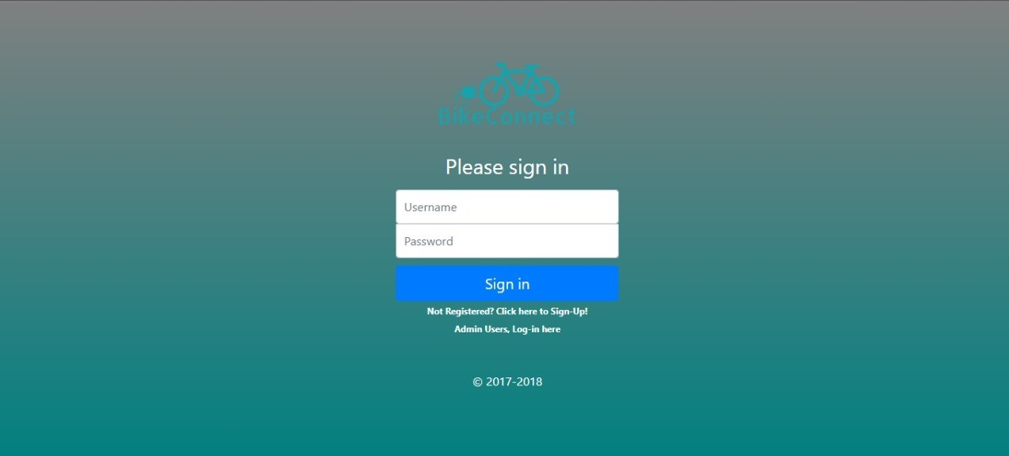

1. **Describe the function of this screen.**
2. **What do you think of this screen? Ex; Appearance, functionality or would you like something added.**
3. **App registration screen**

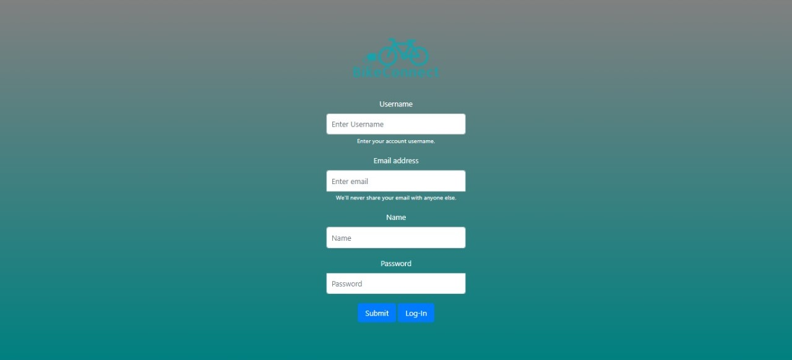

1. **Describe the function of this screen.**
2. **What do you think of this screen? Ex; Appearance, functionality or would you like something added.**
3. **How easy is the registration process in your opinion?**
4. **App welcome screen**

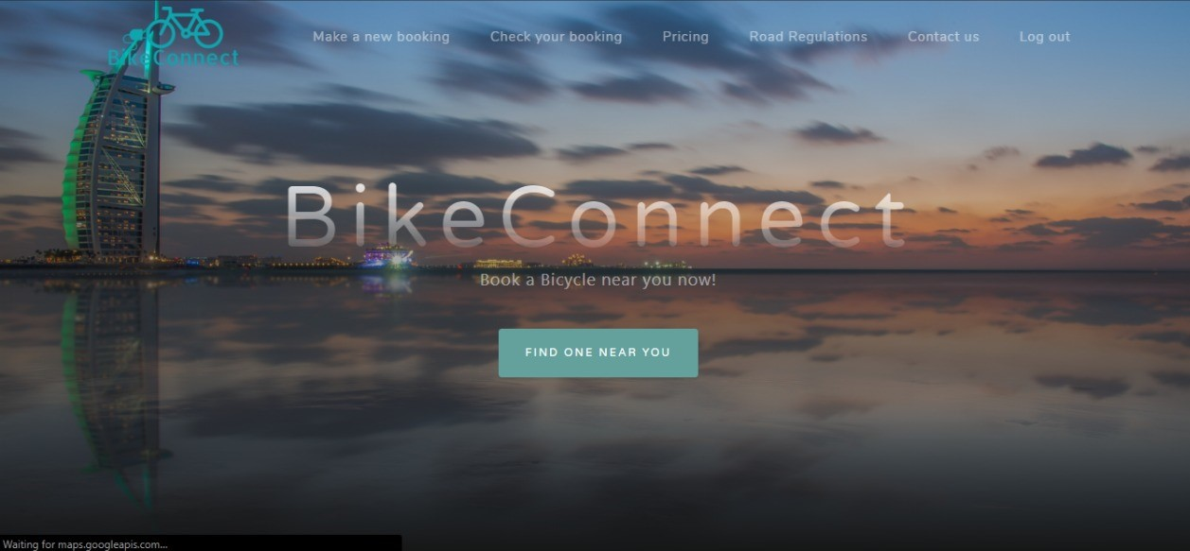

1. **Describe the function of this screen.**
2. **What do you think of this screen? Ex; Appearance, functionality or would you like something added.**
3. **App booking screen**

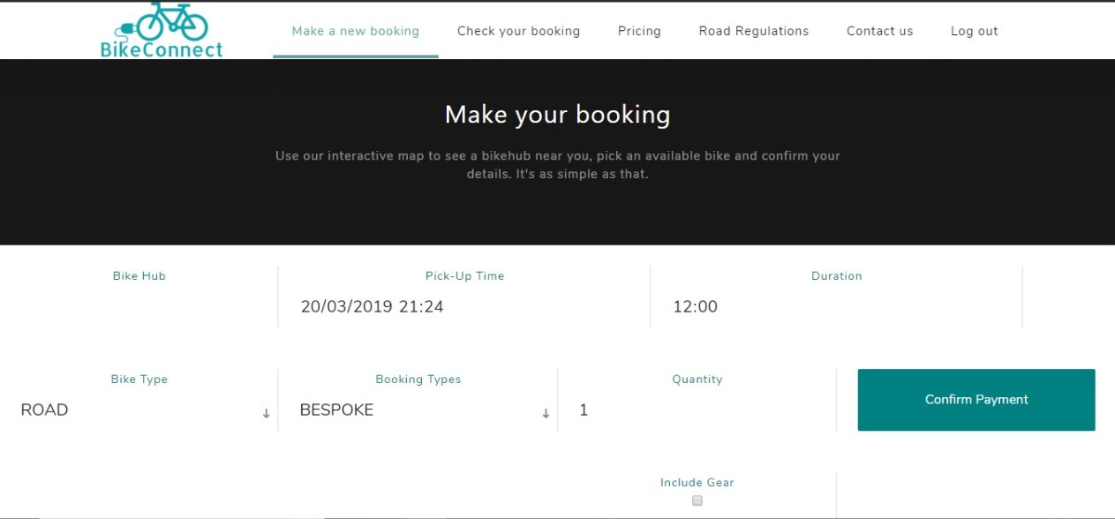

1. **Describe the function of this screen.**
2. **What do you think of this screen? Ex; Appearance, functionality or would you like something added.**
3. **How easy you think is the booking process?**
4. **App booking cancellation page**

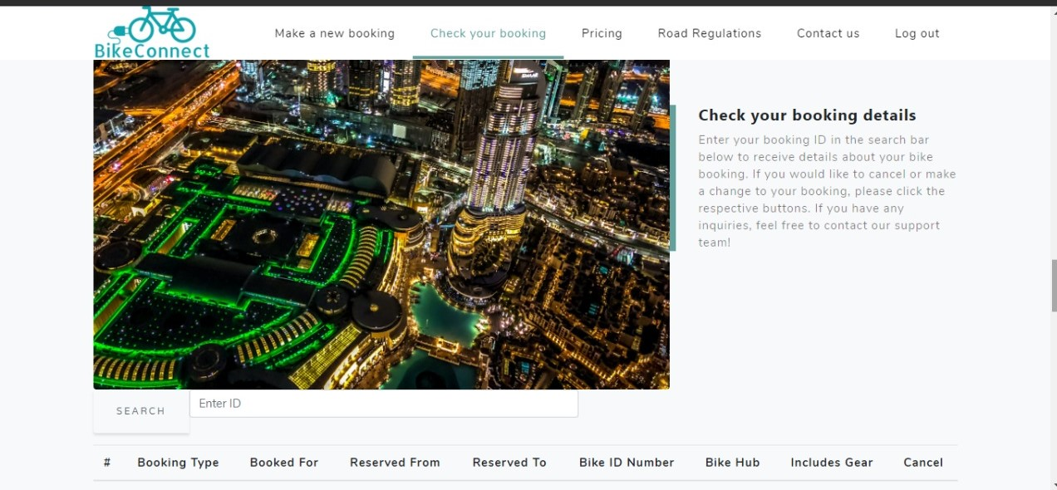

1. **Describe the function of this screen.**
2. **What do you think of this screen? Ex; Appearance, functionality or would you like something added.**
3. **How easy you think is the edit/cancel booking process?**
4. **App general UI design**

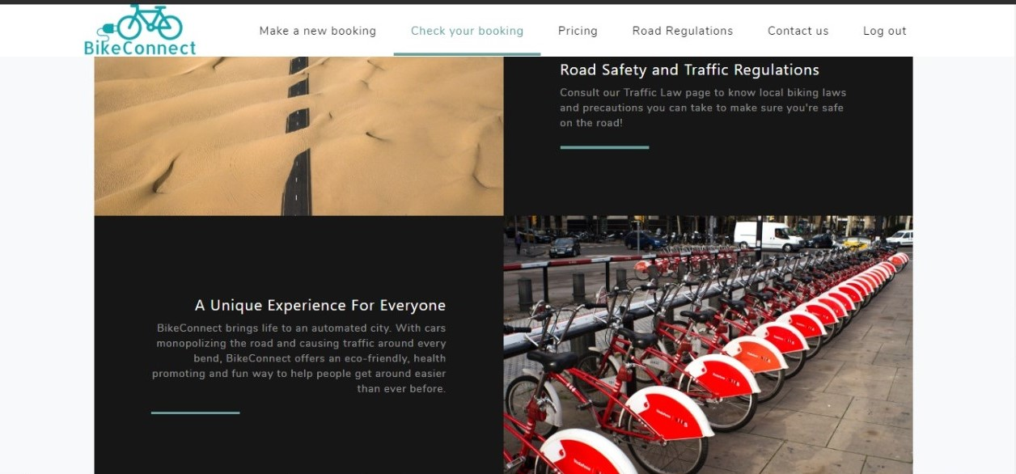

1. **Describe the general idea of the screen.**
2. **What do you think of this screen? Ex; Appearance, functionality or would you like something added.**
3. **App bike map screen**

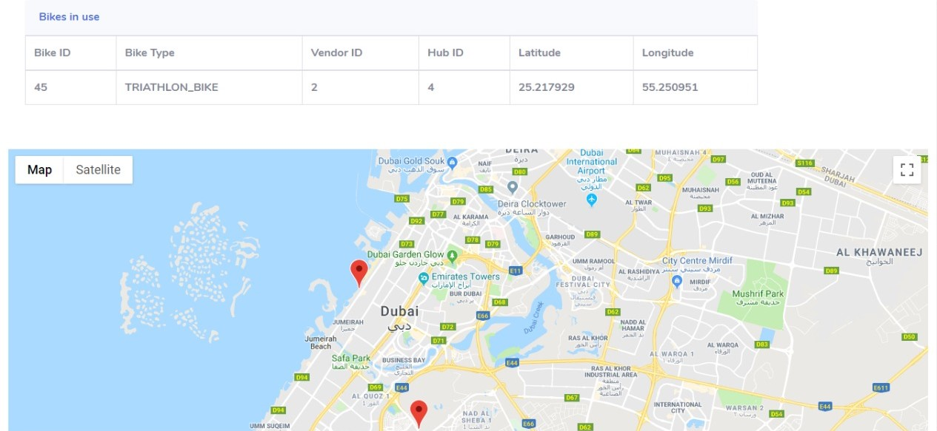

1. **Describe the function of this screen.**
2. **What do you think of this screen? Ex; Appearance, functionality or would you like something added.**
3. **What you think about the feature of live geographic location of bikes and hub?**
4. **App pricing page**

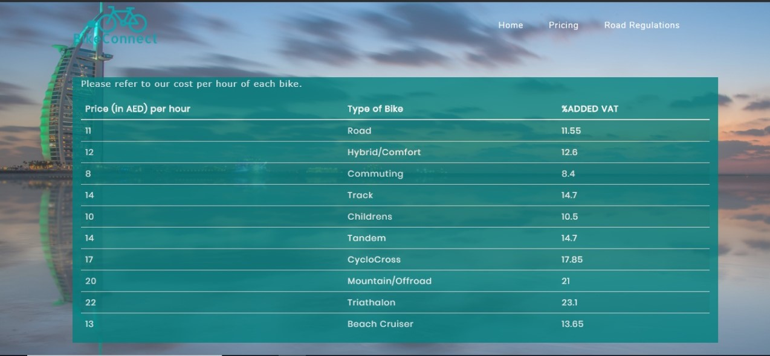

1. **Describe the function of these screens.**
2. **What do you think of this screen? Ex; Appearance, functionality or would you like something added.**
3. **Would you like to have any other type of bike added in the list?**
4. **What you think about the prices?**
5. **App rules & regulation screen**

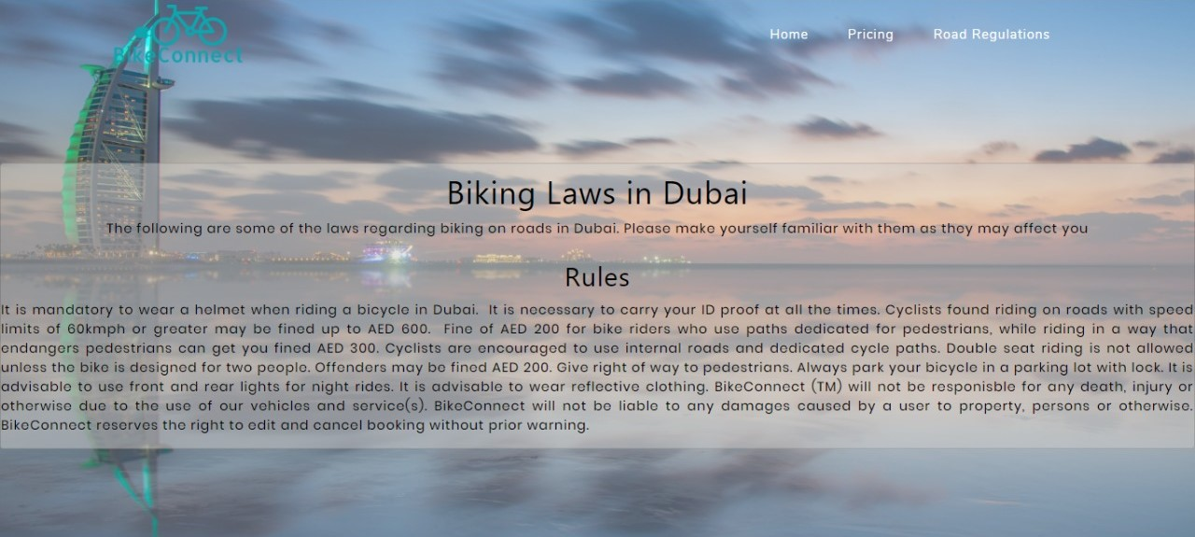

1. **Describe the function of this screen.**
2. **What do you think of this screen? Ex; Appearance, functionality or would you like something added.**
3. **How is the idea of getting users familiar with cycling rules and regulations?**
4. **App complaints screen**

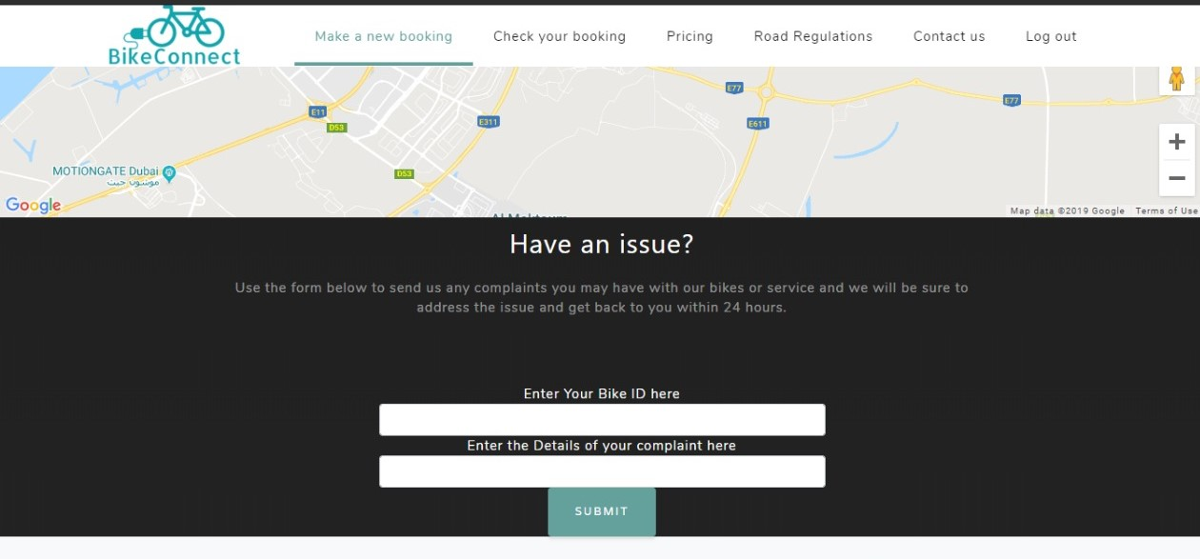

**Figure 1 User view**

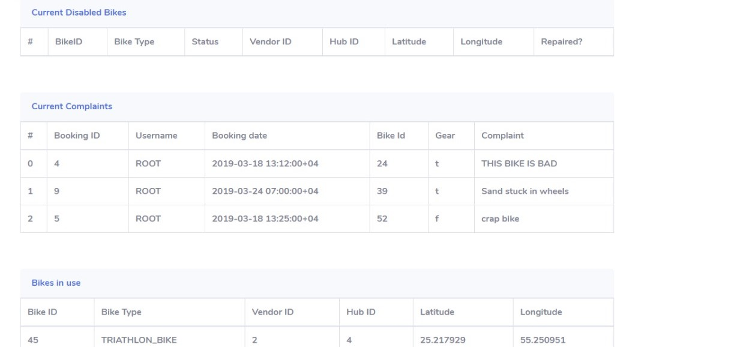

**Figure 2 Admin view**

1. **Describe the function of this screen.**
2. **What do you think of this screen? Ex; Appearance, functionality or would you like something added.**
3. **How much did you like the idea of getting and solving customer complaints?**

**Questionnaire (Exit):**

**Q1. I think I would like to use this app frequently.**

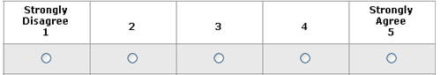

**Q2. The overall user interface design seems to be great.**



**Q3. I found the app unnecessarily complex.**



**Q4. I thought the app was easy to use.**



**Q5. I would imagine that most people would learn to use the app very quickly.**



**Q6. I felt confident using the application.**



**Q7. I will recommend others to use this app.**



**Q8. What do you most like about this application?**

**_________________________________________________________________**

**Q9. What do you least like about the application?**

**_________________________________________________________________**

**Q10. What changes would you like to see in this application?**

**_________________________________________________________________**

4.0 Testing and Questionnaire Findings

4.1 Questionnaire Numerical Results

|  |  |  |  |  |  |  |
| --- | --- | --- | --- | --- | --- | --- |
|  | Particpant 1 | Particpant 2 | Particpant 3 | Particpant 4 | Partcipant 5 | Particpant 6 |
| Q1 | 4 | 3 | 4 | 2 | 4 | 3 |
| Q2 | 4 | 4 | 4 | 4 | 4 | 4 |
| Q3 | 1 | 3 | 2 | 1 | 1 | 2 |
| Q4 | 5 | 3 | 4 | 5 | 5 | 4 |
| Q5 | 5 | 4 | 4 | 4 | 5 | 4 |
| Q6 | 5 | 4 | 5 | 4 | 5 | 5 |
| Q7 | 5 | 4 | 5 | 2 | 4 | 4 |

4.2 Test and Questionnaire Subjective Results

1. **App sign -in page**



The testers were unanimously clear about the function of the page however the design did have criticism mainly that it was a bit bland to some of the testers, other comments:

* Eye-catching sign-up button
* Logo blends into background and looks ugly
* Needs images on what type of services the site provides
* Could use some sort of social media application buttons

1. **App registration screen**



The testers generally liked this screen citing simplicity and clear design as positives and clearly understood the purpose however there was some criticism:

* Could use a captcha in order to prevent bots from creating fake accounts
* Name is not very clear (full name or just first name?)

1. **App welcome screen**



The testers generally understood the function of the main menu and liked the design but there was some feedback:

* The options at the top are not very visible and the logo looks cut out
* Could use a FAQ section in order to help new users figure out what is going on

1. **App booking screen**



The testers generally understood the purpose of this section and the design was simple there was some feedback:

* The design is simple if you understand what your doing but for a new user could be complex
* The duration box should be in number of hours

1. **App booking cancellation page**



The purpose of the section was well understood but there were some responses:

* The picture is unnecessary and makes things more confusing
* Why do I need to remember my booking ID, just display all my bookings
* Booking ID will not be easily remembered and then what?

1. **App general UI design**



The testers generally enjoyed the design and the UI of the application with no real feedback coming back from this section.

1. **App bike map screen**



The testers were pleased with the functionality of the page and its purpose with the main criticism being:

* The GPS location of the bikes could be used for malicious purposes
* Displaying the latitude and longitude of the bikes is not the best solution

1. **App pricing page**



Testers indicated that the page’s purpose was well defined and easy to understand, the feedback was:

* No need for the third column (tax)
* Could have this displayed on the main page
* Seems expensive pricing
* Seems cheap pricing

(NOTE: The pricing comments, the fact they both contradict each other, is explained by the fact that pricing for this sort of service has a wide degree of variation depending n the region.)

1. **App rules & regulation screen**



The purpose of the page was easily identified by the testers and was praised as a great idea, however there was one major criticism:

* Too much text, wall of text, better to display in bullet points or in short single lined sentences.

1. **App complaints screen**



**Figure 1 User view**



**Figure 2 Admin view**

The testers again understood the function of this section and saw the usefulness of the feature however the complaints were:

* Instead of a text input how about a drop-down box with common complaints
* Again, with remembering the bike ID, not the way to do it.

**Q8. What do you most like about this application?**

**_________________________________________________________________**

Answers included:

* Simplicity of the design
* Complaint/reporting feature
* The bike hub system for pickup of bikes

**Q9. What do you least like about the application?**

**_________________________________________________________________**

Answers included:

* The map design was too large and confusing, not very user friendly
* The legal page was too clustered and needed spacing/redesigning

**Q10. What changes would you like to see in this application?**

**_________________________________________________________________**

Answers included:

* Visual touch ups
* Social media integration
* Chat functionality with customer service

5.0 Conclusion

The conclusion of the testing is discussed and analysed in detail in the (D.) Project Evaluation section of this report.

6.0 Appendix

6.1 Consent From

Consent form for usability experiments:

BikeConnect Mobile application

Heriot-Watt University

**Consent to Act as a Subject in an Experimental Study**

**Principal Investigator**: Hassan / Cerdic / Ryan / Swapnil / Ishaq / Pavan

**Description**: The purpose of this study is to study is to test the usability and functionality of the BikeConnect mobile application. As a result of this study the mock-up or beta version of this application will have it’s errors fixed and improvements made to better its final product for the end user.

There are minimal risks for you to participate in this study. All personal information will be kept confidential in a secure filing cabinet or in password-protected computer directories. Your participation will not affect how well you do in your courses (if you are a student) or affect your relationship with the university in any way

You are free to decline to participate in this study. Should you decide to participate, you are free to end your participation at any time. Such a decision by you will not adversely affect or alter you status with the university in any way.

**Voluntary consent**: I certify that I have read the preceding and that I understand its contents. Any questions I have pertaining to the research have been and will be answered by the team. My signature below means that I have freely agreed to participate in this study, and that I agree to the publication of the results for scientific purposes and to the distribution of the recordings and transcripts of the sessions for research purposes so long as my identity is not revealed.

________________ ______________________________ __________

Date Subject Signature Inv. Initials

**Investigator's certification**: I certify that I have explained to the above individual the nature and purpose, the potential benefits, and possible risks associated with participation in this research study, have answered any questions that have been raised, and have witnessed the above signature.

________________ _______________________________

Date Investigator Signature

C. Final Application Design and Implementation

1.0 Scope and High-Level Overview

BikeConnect is a web application designed for people looking to rent out a bicycle for a duration of time from specified points around Dubai, this can also be classified as a solution for the last mile travel as using a bicycle allows for greater accessibility than other transportation solutions. The system not only allows for bookings but also for complaints/reports to be submitted all to the PostgreSQL server in place accessible, with varying degrees, by both users and managers/operators.

The components of the system include:

* + - User login with personal accounts that utilize secure token per session
    - Making a booking with customizable options (bike type, time, duration, include gear, etc.)
    - Legal requirements alert and notification system
    - Processed booking can be canceled by the user
    - A user can submit complaints and reports about their rented bike
    - Google Map API for the display and selection of bike hubs
    - Operator/Manager with personal accounts that utilize secure token per session
    - Operator/Manager area that displays statistical data and daily summary reports of the system
    - Operator/Manager can order redistribution and repair or individual bikes

The technologies used to implement the features of BikeConnect are:

1-Apache Cordova

Apache Cordova is an application development framework that allows us as developers to export the BikeConnect app to any platform we desire. In this case IOS, Android and browser, etc. While allowing us to use HTML and JavaScript as our language of choice which includes Ajax, jQuery, and XMLHttpRequest.

2-JavaScript (JS)

Java scripts allow the HTML pages to change dynamically according to a user’s input rather than having a static unchanging page and can edit the HTML file as it is being displayed. This is especially useful for changing components of the webpage such as the maps, tables as well as some fields of the form in BikeConnect that are queries directly from the database. This is especially useful since porting to any platform that isn’t browser assumes post directories to be local files which aren’t the case in making web apps, instead of using XMLHttpRequest information is assumed to be outside the machine and can post a PHP script hosted on a server without redirecting the user to the PHP file.

3-Google Maps API

Google Maps makes it easy for users to find bike hubs and admins to keep track of bikes. This removes the hassle of having to enter the address of the bike hub manually or taking excessively long to book a bike.

4-PostgreSQL

PostgreSQL is a database management system (DBMS) that allows the storage and organization of large amounts of data, which in this case is the information about bikes, hubs, and users as well as any data relating to the BikeConnect app.

We picked PostgreSQL for its faster read and write speeds in comparison to MySQL. It is more resilient stable and secure than MySQL. It is built with ACID (Atomicity, Consistency, Isolation, Durability) compliance and native SSL support for client-server communication. While PostgreSQL is an excellent DBMS, inheritance behaves differently from how it does in MySQL. In MySQL, a single sessions table may contain session information for both users as well as staff/admin accounts as the staff/admin tables inherit fields from the user’s table, however, in PostgreSQL this requires two separate tables and inheritance is a shortcut to creating tables rather than a derivative of an existing table.

5-PHP

PHP is the interface between the app and the PostgreSQL server it allows data to be read and edited in SQL database. The app posts requests to PHP script files that interact with the database and verifying what and/or who is requesting data from the server and can deny or allow requests according to how it was scripted.

We used to create md5 hashed passwords and secure session tokens for tracking login sessions and allowed for large amounts of data to be sent and received that proved crucial for some areas in the web app. Tokens are used to verify users that request data from the SQL server and as an alternative for storing passwords locally as they could be deleted and be stored locally without compromising the accounts information by giving away its password as it is independent of it. Md5 hashing of passwords means no one can read the users password even if they’ve received access to the md5 code as it is difficult to reverse an md5 code to get a user’s password. Each request to the PHP from both users and admins carries the username and secure token to validate the identity of the request and prevent any unauthorized or unnecessary querying of data that could be taxing on the server. Taxing and critical queries such as booking that handles excluding bikes unavailable bikes and including available bikes to be booked at a specific time should not be done unless the user is verified first especially in the case of BikeConnect since this is handled by the server and books bikes automatically according to their availability rather than user selection.

2.0 Design Methodology

The design methodology for front and partial back end of BikeConnect, as per the individual primary components in the development and design of the application, will be listed below:

2.1 Front End Web Application

The front-end web application consists of the entire user and manager/operator part of the BikeConnect application with all the pages being developed with HTML and CSS as the base code. As mentioned above JavaScript was used throughout the application in order for the pages to change according to the user’s input, the google map API was also used on both ends of the application, user and manager/operator, in order to provide an accurate and responsive map.

2.2 Application Development Framework

The application development framework used in BikeConnect was Apache Cordova that allowed for easy porting to both Android and IOS mobile operating systems. It is used extensively with BikeConnect in order to provide these features and to reduce development time.

2.3 Interface with PostgreSQL Database

In order to allow for interface with the PostgreSQL, database PHP is used that allows for editing and querying of the database. This, as mentioned above, is used as a security feature but also when creating/canceling bookings, submitting reports/complaints, creating a new user account and removing repaired bikes from the list of broken bikes in the managers/operators view.

3.0 Database Design

3.1 Design

The design of the database ensures that data is categorized by their meaning/task, therefore, reducing the duplication of data. By doing this, however, it can become very difficult to start to query effectively as you would need to either pull/push data to/from a variety of different tables with different links between one and other. Therefore, we created a variety of views whereby querying becomes much simpler as all the data that needs to be queried is already organized as per the task or the subject.

The many to many relations in our database design had to be addressed, therefore supplementary tables (EWC and BB) were added to get rid of them. Our initial design of the database was to be as efficient in querying as possible in order to keep memory usage down but also to allow for efficient and fast querying.

3.2 Database Diagram

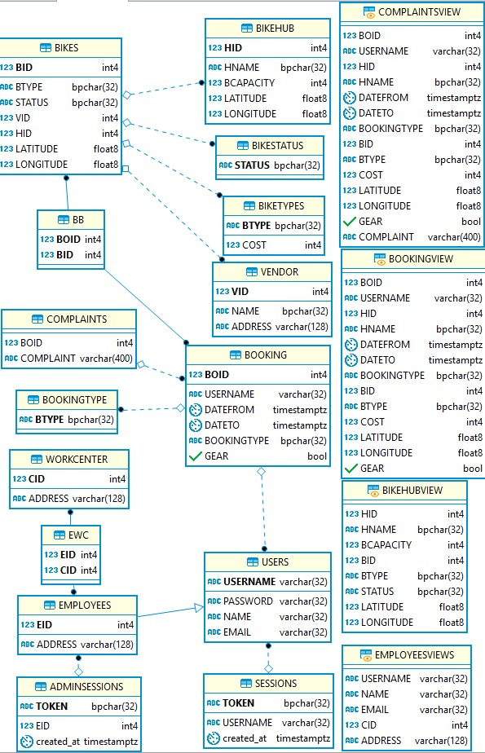

4.0 UML Diagrams

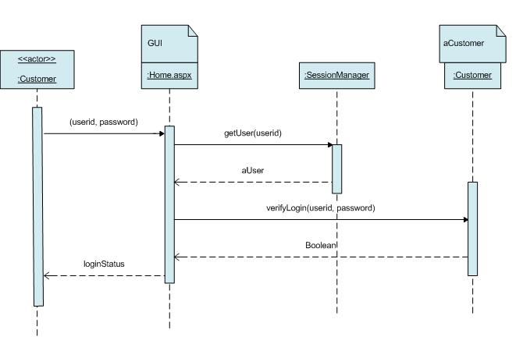

The above sequence diagram shows how users log in to the system from a high-level point of view.

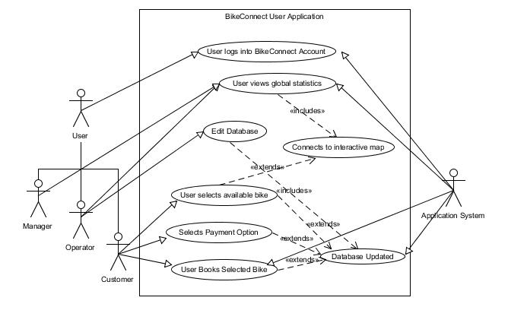

The above UML diagram shows the working of BikeConnect and the connections between the varying systems.

5.0 Final Interface Design

5.1 Introduction

The UI for the application accommodates 3 types of users, Guests, Registered Users, and Admins:

* Guests can view the home page and the sign-up page of the website allowing them to register to the website.
* Registered Users are the primary account type, allowing them to access the core features of the website, to make and cancel bookings and check on existing bookings.
* Administrators have access to all parts of the website and the back-end data.

5.2 Site map

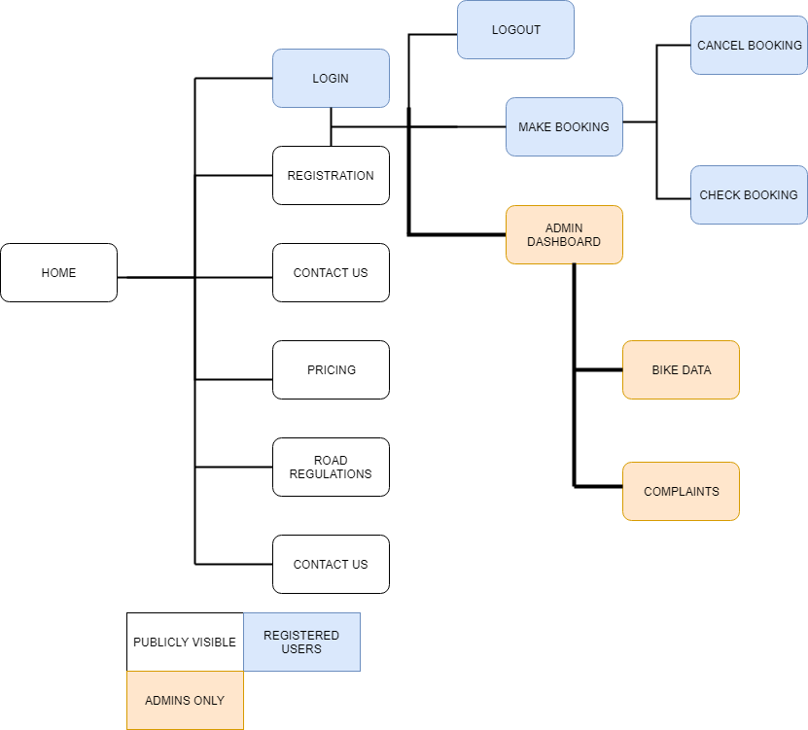

This site map gives an overview of the site’s navigation structure and how the pages and information connect with each other. Each of the access levels are highlighted and separated. Publicly accessible pages is accessible by anyone while the other pages are differentiated by who can access them, while administrators can access the pages that registered users can as well.

5.3 General Interface Design

Header Navigation

BikeConnect has a very compact and responsive navigation system that can be used very easily using the bar. This always helps keep everything in front of the user, making sure the user is aware of the major functions of the site while keeping in line with the minimalistic design the rest of the website adheres by.

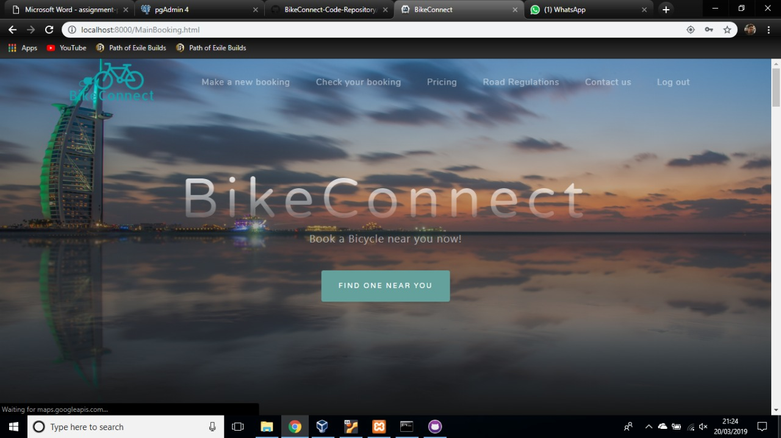

Design decisions and observations

We wanted the functions to be easily visible and since the beginning of the project and initial design of the project, it was meant to be very minimalistic. This helps keep it clean and highlight the parts of the app that was important. We had our designer make a logo to complement the atmosphere with the rest of the application.

Colour Scheme

The colour scheme of the app was meant to be calm and highlight the appropriate parts of the app. The colour scheme was also meant to look attractive to a wide audience.



These are the primary colours of BikeConnect.

Minimalistic Design

The Minimalistic design of BikeConnect required a lot of blank spaces to make sure that the user didn’t get overloaded with data it also helps keep the navigation clear and obvious since its design stays the same and is very clear cut. Hence, to highlight different parts of the app, you either add more things or add blank space to highlight the parts that are important.

5.4 User Interface Design

Screenshots and Analysis

Landing Page

This is the app’s welcome screen and is meant to catch the user’s eye and make sure that the home screen doesn’t overload the users with data.

App registration screen****

This screen helps guests who want to utilize the main functions of the app do so by registering and is kept very clear of any distractions, this also helps make it seem familiar when using it on a mobile device.

App Sign-In Page



This page follows the same principles as the Sign up page making sure that the page seems familiar helps make sure that users have an ease of access due to their familiarity of it.

App booking screen



This screen helps people make bookings and confirm the payment, it allows you to choose what type of bike, the time and date. It then proceeds to give you a booking ID.

****Booking Cancellation Page

This page helps users lookup details using the previously mentioned booking ID and cancel the booking if required.

App Bike Map Screen



This Screen tracks the bikes and bike hubs for the app and allows users to click on it to book a bike at the marked bike hubs.

The Pricing Screen



This helps users figure out the prices of bikes depending on the type of bike too.

Rules and Laws Screen



This page helps users find out all the laws of biking and keeps you informed before you book or use a bike.

The User Review Screen



USER VIEW

This View helps people make complaints about their bikes and send feedback to the admins.

5.5 Manager/Operator Interface Design

Admin Bike Tracking

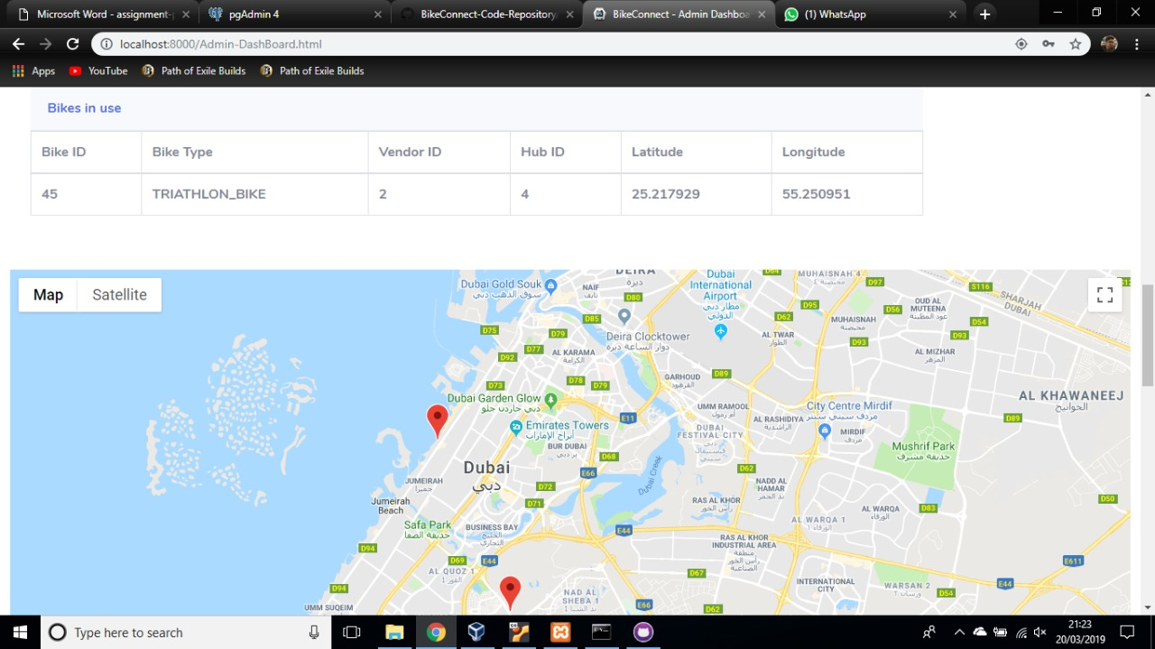

This Screen allows admins to track the bikes, their IDs, the location and the hub.

Admin Dashboard 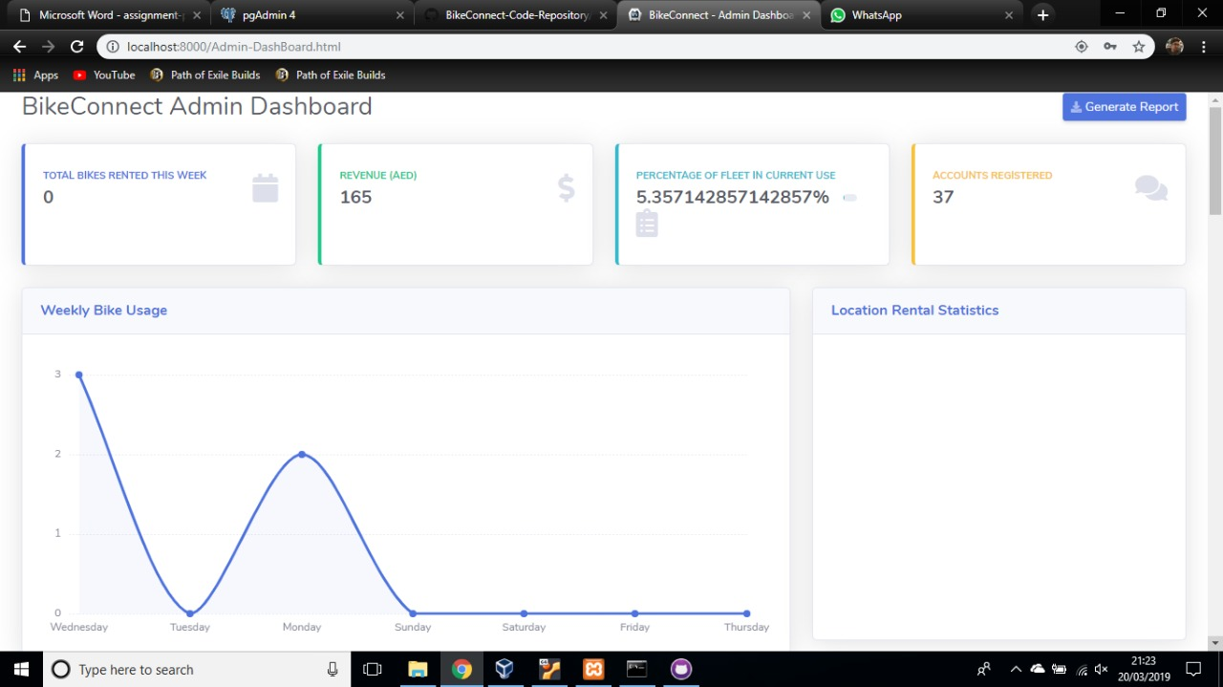

The admin dashboard helps admins generate reports and keep track of the data about the app and bikes and such.

6.0 Implementation Methodology

The implementation methodology that was used during the development of BikeConnect was SCRUM an agile methodology focusing on short sprints with specified goals for each week and the confirmation and testing of achieved goals by the end of the week. In stage 1 a Gannt chart was created that outlined the weekly sprint tasks that were to be completed, however as is usual in SCRUM the final decision on the week tasks were taken during virtual meetings that the group leader organized each week to see what the progress was and what would be decided for the upcoming week. The group leader acted as the SCRUM master keeping the team on track, making sure that productivity remained high and attempting to remove distractions from the SCRUM team.

The full Gannt Chart is viewable in stage 1 of BikeConnect development reports however due to some changes in the actual goal specifications and the variations in week to week productivity and success this schedule was not kept too very accurately. Below is a more updated table on what was completed in the weeks from 06/01/19 – 24/03/19

|  |  |  |
| --- | --- | --- |
| Week | Tasks | Status |
| Week 1 | * Database Initial Setup * Initial HTML and CSS Mockups | Partially Completed  Completed |
| Week 2 | * Database Initial Setup * Creation of Log in Pages | Completed  Completed |
| Week 3 | * Database Fully Functioning * Creation of Navigation and Main Booking Page | Completed  Partially Completed |
| Week 4 | * Database Queries in PHP * Initial Apache Cordova set up * Creation of Main Booking Page * Creation of admin page * Implementation of booking a bike | Completed  Partially Completed  Completed  Completed  Completed |
| Week 5 | * Apache Cordova set up * Querying data to admin page | Completed  Partially Completed |
| Week 6 | * Create JavaScript for current achieved functionality | Completed |
| Week 7 | * Google map API * Querying data to admin page * Creating data views in admin page | Completed  Completed  Partially Completed |
| Week 8 | * Address issues with Cordova * Implement report/complaint system * Add multiple bike types * Add price page | Completed  Partially Completed  Completed  Not Completed |
| Week 9 | * Finish resort/complaint system * Add price page * Add legal page and notifications * Improve UI * Update database * Add test data to database | Complete  Complete  Complete  Partially Complete  Complete  Complete |
| Week 10 | * Add the retrieve and cancel booking feature * Display broken bike on Admin page * Improve UI | Complete  Complete  Partially Complete |
| Week 11 | * Improve UI * Add gear selection * Add PayPal API for payment * Create booking confirmation page | Complete  Complete  Partially Complete  Partially Complete |
| Week 12 | * Enhance Apache Cordova * Port to Android and IOS * Finish the JavaScript | Completed  Completed  Completed |

The SCRUM Implementation methodology worked well for us as it allowed for rapid reorganization of the week’s tasks, kept the team in somewhat of a focused view on the task at hand and allowed for quick testing that happened at the end of each sprint in order to ensure quality assurance. The team’s relative lack of expertise was the reason we chose this method over others as it revolved around the whole team working towards a common goal therefore, we felt that the combined knowledge would empower us to achieve and complete difficult tasks more effectively.

7.0 Testing for Technical Correctness

Due to the SCRUM implementation testing was carried out weekly whenever a SCRUM cycle was completed, therefore most of the testing happened by the team member(s) who developed that part of the application. The testing depended on the task completed but with the HTML and CSS pages the pages were loaded up into a browser where they were checked for correctly displaying as well to check if it was functioning as desired. With the JavaScript, it went much the same way however once the page was opened the page was then manipulated in order to see if the inputted data, or requested data from the database, would be loaded without refreshing the current page. To test the PostgreSQL database dummy data was loaded into it and then the database was queried in order to see if it functioned correctly, it was also queried to see if inputted data from the website was handled and stored correctly and efficiently.

The PHP queries were all tested when they were used if used once the query had run the team member would open via the administrative database view and check that the data had been correctly stored into the database. To check if the query pulled data correctly, in the browser the query would be run and the output on the page would be checked with the known dummy data that had been stored into the database. The final testing was conducted on the Google maps API that was easily tested when the browser opened as the API had to load the map and then all that needed testing was if the locations of the bikes and bike hubs were being displayed correctly.

The final system was tested by combing all these tests into a multitude of use cases that were then run through by the development team in order to emulate what real-world use would do to the application. These use cases included 1. A new user will log in, create a booking, delete the booking, create a new booking, and finally report a complaint. Number 2 was a manager who would log in and check the status of the system in the manager/operator view, then check the complaints and finally order bikes to be repaired. These two use cases test all the major functional requirements that we had set out to complete. After the use cases had been carried out the database was checked to see if the proper data had been queried or deleted as per the instructions of the use case.

8.0 User Guide to Set Up BikeConnect

8.1 Textual Guide

**Step 1: Environment Setup and Required Files/Directories**

The first step of setting up the BikeConnect website and server-side applications is too acquire the required files. The main GitHub code repository should have been uploaded onto the submission link and contains all the code we developed during the project. The files structure is as follows:

* The main folder will contain two subdirectories which are the “BikeConnect” and “Server Setup” folders. These contain the web application code (HTML, CSS, JavaScript and other files) and the server-side code (PHP, AJAX) respectively which are the foundations of the application.

The “BikeConnect” folder itself is also the directory from which we ran Apache Cordova from (more on how to compile and run this later). Please Follow the following steps to proceed to the Running and Application Setup section of the manual:

* **Download the latest version of the following applications:**
  + - Node JS for the installation of Apache Cordova

<https://nodejs.org/en/download/>

* + - Apache Cordova (by running these commands: sudo npm install -g cordova. For Linux or npm install -g cordova. For Windows). <https://cordova.apache.org/docs/en/latest/guide/cli/>
    - PostGreSQL and PGAdmin (for administrating the database). Please **set the username to postgres and the password to “342910841”** when prompted to. This will allow your local account to sync with the code we have produced. Please only proceed with this step after you have installed XAMPP as PostGreSQL needs to be installed inside the XAMPP main directory to successfully allow XAMPP to host the server. Skip this step if a domain is being used to host.

<https://www.postgresql.org/download/>

* + - An active internet connection is required to connect to the bootstrap CDN as well as any other online libraries we have used for our designs such as ColorLib.
    - XAMPP is required to host the local server unless a domain can be provided to host the website on. This is how we developed and displayed our demo product and can be used for testing purposes as expected.

<https://www.apachefriends.org/index.html>

Localhost IP address should be set default to 127.0.0.1 but if not, please change it to match. Please access the php.ini file located within the XAMPP directory in the drive you have installed it to and change the following:

* + - * **extension=php_pdo_pgsql.dll and extension=php_pgsql.dll should be uncommented so remove the semi-colon in front of them.** This will enable PGSQL to correctly run on the XAMPP platform. Please remember to install PostGreSQL into the XAMPP directory to avoid errors.
      * Run the PGAdmin tool and create a database after entering your password for the user postgres (which you should already be in). Call the database “bikeconnect” with the exact spelling to allow the server to be loaded properly with our code. Next is to check if the command “psql” is working on the cmd (if you are on windows OS) by typing “psql bikeconnect postgres”. You should receive a request to enter your password. If not, refer to the next step.
      * Set your Windows Environment Variable to include the file path for your postgres folder. Do this by opening control panel, navigating to users, user accounts, then on the left panel, selecting change your environment variables. Select the PATH option and select edit. Add the file path with a semi-colon in front of it to the bottom of the list and try running the “psql” command again from your terminal.

You should now be fully set to host the BikeConnect Application from your computer or personal server. Proceed to the next step to run the Application.

**Step 2: Running the Server and Application and Results.**

* Start the Apache Server from XAMPP and **add to the htdocs of the main XAMPP folder, ALL the files from the htdocs folder located inside the “Server-Setup” Folder from our code repository you downloaded.**
* Start PGAdmin and connect with your password if prompted. You can see the updated tables by navigating to Schema, Tables, then right-clicking view data to see the entries being added when data is entered on the website.
* Loading the data onto the database can be done by typing the command “psql bikeconnect postgres” into the terminal and then entering the password which was given to you earlier in the document (**“342910841”**). Once this is done, open the all(1).txt file in the “Server Setup” folder of the code repository and copy paste this into the terminal. This will update the database with the test data we authored to provide an accurate estimation of the system running at full capacity. You may if you wish, add data upon this collection.

Navigate to the Main BikeConnect folder which was mentioned before to be the same folder that Apache Cordova recognizes as a build folder. Since it has already been compiled as an Apache Cordova build folder, it does not need to be compiled again so simply typing the following command should suffice: “cordova run browser”. The web-application should now be fully running and should work without error. If you would like to view the application on the Android or IOS platforms, any of your preferred emulators for the PC can be used and will be recognized by Apache Cordova when you run the following command “cordova run android” or “cordova run ios”. If there are any issues, please do not hesitate to contact a member of the team and we will revert with an updated copy of this manual and address the issue as fast as possible.

8.2 Visual Download Guide

Download page for the latest versions of PostGreSQL for most platforms. The latest version is the one we used for our project. This should install the package installer for PGAdmin as well as the command line package which gives the user the option of editing the database using manual SQL queries in a text file pasted onto the command line or by using the admin tool.

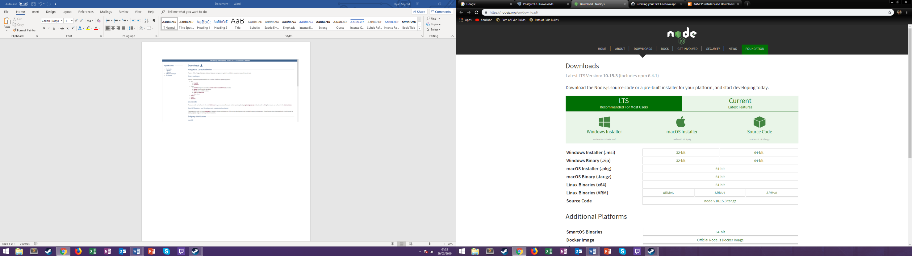

Node JS is required to make Apache Cordova function and thus is required. The latest version is the one we used for our project. If Linux Operating System is being used, one can use the command line to install Node JS as well.

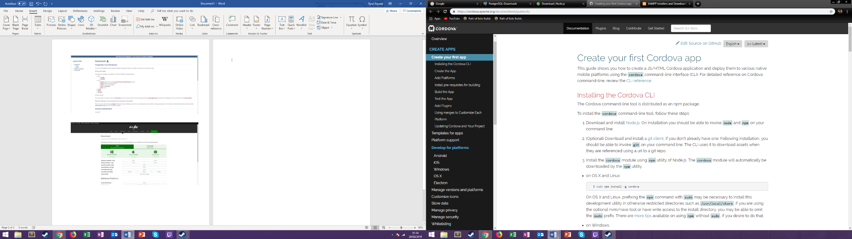

Apache Cordova was the technology we used to make native applications of our web-application on Android and IOS without having to code for them. Our Code Repository is already a cordova build file, so any extra compiling is not required. This installation can be done for any platform on the command line and enables the user to use the cordova command to compile and run the various applications. Cordova also will automatically call any emulators installed on the PC when a request to run on a certain platform is called.

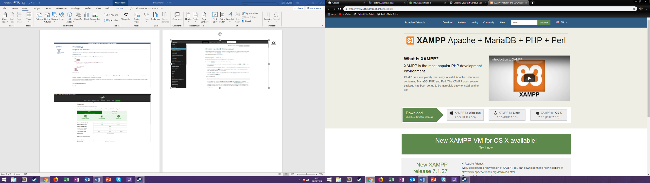

Since we did not purchase a domain name for our web-application, the next best thing and most convenient for developmental purposes was to use a localhost running on XAMPP. We did, however, have to enable PGSQL on the port component so that we could host the server successfully on the localhost. Refer to the User Manual included in this document to learn how to enable PGSQL in XAMPP.

D. Project Evaluation

1.0 Organization

1.1 Group Organization

The group was organized via the provided method for this task with the 5 defined roles each with their own responsibilities and tasks. The assignment of these roles happened at our very first group meeting where democratically the group leader was voted on and then roles were somewhat allocated/requested. The group roles have not changed since then and the group leader has never relinquished command over the group, the roles are:

|  |  |
| --- | --- |
| **Name** | **Role** |
| Cedric Ecran | Project Manager/Group Leader (PM) |
| Ryan Sayeed | Technical Co-Director (Head of Front-End Development (TDF) |
|  |  |
| Ishaq Marashy | Technical Co-Director (Head of |
|  | Server/Database) (TDS) |
| Swapnil Aggarwal | Liaison Officer (LO) |
| Pavan Mankani | Reporter (R) |
| Hassan Subzwari | Documenter (D) |

This group organization played well on people’s strengths and put important roles with the people who contributed the most to the project. Also, our technical directors did an outstanding job in leading the team forward by quickly learning and implementing new and difficult technologies. The organization of the group worked out very well as unfortunately three of the group members were very lackluster in doing work (either coding or documentation) towards the project and fortunately their roles did not require them to take a leadership role.

1.2 Group Collaboration

The group collaboration had mixed results with stage 1 having good to average collaboration between the entire group. The entire group worked well on the creation of the stage 1 documentation and proposal with good communication and regular meetings taking place throughout the first semester. This all changed once stage 2 commenced as one of the group members disappeared off the radar for nearly 2 whole months with no contact from him what so ever and even missing the stage 2 demonstration to our line manager. Additionally, two other members of the group also became very distant by not attending the sprint meetings and not contributing very much to product development. This brought the moral of the group down significantly and forced us to change the development goals as the group had effectively downgraded to just 5 members whereby only 3 of them were actively developing the application.

Once stage 3 began the group member who had disappeared finally returned and provided some valid contribution to the Expo presentation and this report. This combined with the two group members also helping to contribute to the team morale. The stress and strain of 3-man software development had however forced a rift between the three-group member who had worked on the development of the application and towards the end, this affected the final sprints. Below are screenshots from GitHub the version control tool we used in developing the application highlighting those group members who contributed to the development of the application.

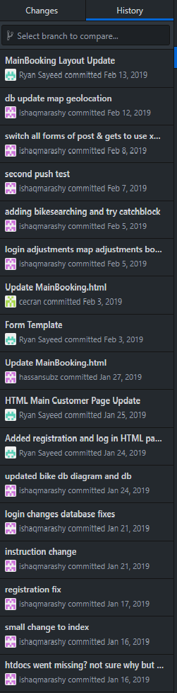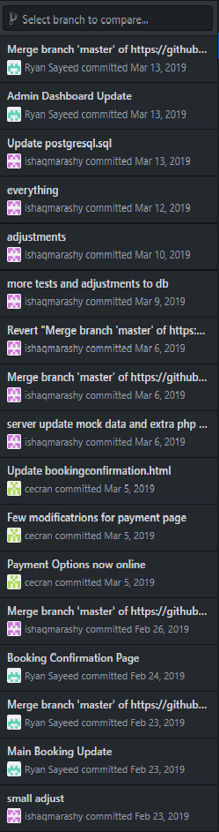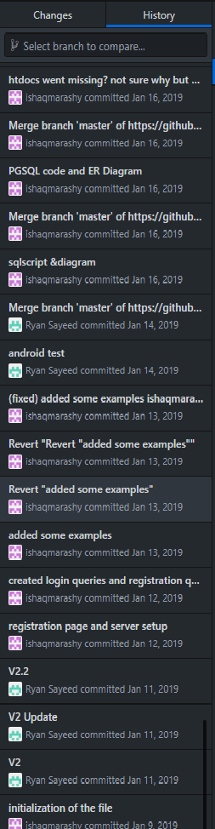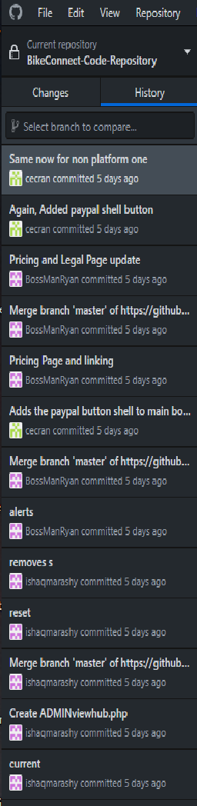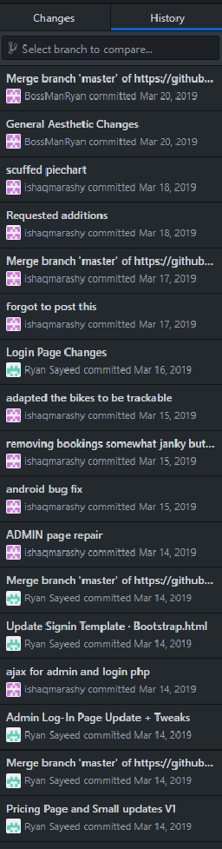

This is added in the hope to allow for transparency when it comes to understanding the group dynamic and the amount of work that some team members have contributed to this project. Another problem with the collaboration was one of the team members in the final days of our submission of the final report, the very one you are reading now, had planned a flight back to their home country and effectively contributed very little to the actual writing portion of this report.

1.3 Original vs Actual Implementation Schedule and Plan

Due to the above-highlighted problems within our group the original plan was heavily modified and changed to accommodate the amount of work that could be expected by only three group members, that lead to major changes in the timeline of development. The original timeline is linked below:

|  |  |  |  |
| --- | --- | --- | --- |
| **Name** | **Begin Date** | **End date** | **Team Member(s)** |
| Stage 1 Initialization | 04/10/18 | 11/10/18 |  |
| Group Assignment | 04/10/18 | 04/10/18 | ALL |
| Communications Set Up | 05/10/18 | 05/10/18 | ALL |
| Role Allocation | 08/10/18 | 08/10/18 | ALL |
| Initial Requirements Overview | 08/10/18 | 08/10/18 | ALL |
| Draft Requirements | 08/10/18 | 08/10/18 | ALL |
| Draft of Project Specifications | 08/10/18 | 08/10/18 | ALL |
| First Line Manager Meeting | 17/10/18 | 17/10/18 | ALL |
|  |  |  |  |
| Requirements | 09/10/18 | 21/11/18 |  |
| Functional Requirements | 09/10/18 | 24/10/18 | TDC, D, PM |
| Non-Functional Requirements | 09/10/18 | 24/10/18 | TDC, D |
| Use Case Diagrams | 25/10/18 | 21/11/18 | TDC |
| Introduction | 09/10/18 | 15/10/18 | TDC |
|  |  |  |  |
| Risk Analysis | 08/10/18 | 21/11/18 |  |
| Consultation with Staff | 08/10/18 | 21/11/18 | R |
| Introduction | 09/10/18 | 21/11/18 | R |
| Risks Compilation | 09/10/18 | 21/11/18 | R |
|  |  |  |  |
| Project Decision and Plan | 09/10/18 | 21/11/18 |  |
| Research | 09/10/18 | 15/10/18 | TDS |
| Introduction | 16/10/18 | 21/11/18 | TDS |
| Project Plan | 16/10/18 | 21/11/18 | TDS, PM |
| Gannt Chart | 06/11/18 | 21/11/18 | PM |
|  |  |  |  |
| Project Costing | 09/10/18 | 30/10/18 |  |
| Research | 09/10/18 | 11/10/18 | PM |
| Cost Table | 12/10/18 | 30/10/18 | PM |
| Cost Table Description | 12/10/18 | 30/10/18 | PM |
|  |  |  |  |
| Usability Evaluation Report | 08/10/18 | 22/11/18 |  |
| UI Brainstorm | 08/10/18 | 05/11/18 | ALL |
| UI Creation | 08/10/18 | 05/11/18 | LO |
| Consent Form | 08/10/18 | 05/11/18 | D |
| Data Collection | 08/10/18 | 05/11/18 | LO |
| Introduction | 08/10/18 | 05/11/18 | LO |
| Test Plan | 08/10/18 | 05/11/18 | D |
| Testing Protocol | 08/10/18 | 05/11/18 | TDS |
| Analysis of Data | 05/11/18 | 22/11/18 | LO |
|  |  |  |  |
| Stage 1 Line Manager Meetings | 17/10/18 | 22/11/18 |  |
| Line Manager Meeting 2 | 24/10/18 | 24/10/18 | ALL |
| Line Manager Meeting 3 | 31/10/18 | 31/10/18 | ALL |
|  |  |  |  |
| Finalization | 22/11/18 | 22/11/18 |  |
| Proof Reading | 22/11/18 | 22/11/18 | ALL |
| Document Organization | 22/11/18 | 22/11/18 | PM |
|  |  |  |  |
| Stage 1 Submission | 22/11/18 | 22/11/18 | PM |
| Peer Assessment Stage 1 | 29/11/18 | 29/11/18 | ALL |
|  |  |  |  |
| Sprint 1 | 22/11/18 | 29/11/18 |  |
| Initialization of Website | 22/11/18 | 29/11/18 |  |
| General Layout | 22/11/18 | 29/11/18 | D, R, LO |
| Brainstorming Design Characteristics | 22/11/18 | 29/11/18 | D, R, LO |
| Initialization of Application | 22/11/18 | 29/11/18 |  |
| General Layout | 22/11/18 | 29/11/18 | PM, TDC |
| Brainstorming Design Characteristics | 22/11/18 | 29/11/18 | PM, TDC |
| Initialization of Server | 22/11/18 | 29/11/18 |  |
| General Layout | 22/11/18 | 29/11/18 | TDS |
| PostgreSQL Self Study | 22/11/18 | 29/11/18 | TDS |
|  |  |  |  |
| Sprint 2 | 13/12/18 | 20/12/18 |  |
| Website | 13/12/18 | 20/12/18 |  |
| Implementation of Design characteristics | 13/12/18 | 20/12/18 | D, R, LO |
| Google Maps API | 13/12/18 | 20/12/18 | D, R, LO |
| Testing | 13/12/18 | 20/12/18 | D, R, LO |
| Application | 13/12/18 | 20/12/18 |  |
| Implementation of Design characteristics | 13/12/18 | 20/12/18 | PM, TDC |
| Google Maps API | 13/12/18 | 20/12/18 | PM, TDC |
| Testing | 13/12/18 | 20/12/18 | PM, TDC |
| Server | 13/12/18 | 20/12/18 |  |
| PostgreSQL Self Study | 13/12/18 | 20/12/18 | TDS |
| Creation of Database | 13/12/18 | 20/12/18 | TDS |
|  |  |  |  |
| Sprint 3 | 03/01/19 | 10/01/19 |  |
| Website | 03/01/19 | 10/01/19 |  |
| Implementation of Design characteristics | 03/01/19 | 10/01/19 | D, R, LO |
| Log in Functionality | 03/01/19 | 10/01/19 | D, R, LO |
| Reservation Functionality | 03/01/19 | 10/01/19 | D, R, LO |
| Testing | 03/01/19 | 10/01/19 | D, R, LO |
| Application | 03/01/19 | 10/01/19 |  |
| Implementation of Design characteristics | 03/01/19 | 10/01/19 | PM, TDC |
| Reservation Functionality | 03/01/19 | 10/01/19 | PM, TDC |
| Log in Functionality | 03/01/19 | 10/01/19 | PM, TDC |
| Testing | 03/01/19 | 10/01/19 | PM, TDC |
| Server | 03/01/19 | 10/01/19 |  |
| PostgreSQL Self Study | 03/01/19 | 10/01/19 | TDS |
| Creation of Database | 03/01/19 | 10/01/19 | TDS |
| Implementation of Data | 03/01/19 | 10/01/19 | TDS |
| Query Testing | 03/01/19 | 10/01/19 | TDS |
|  |  |  |  |
| Sprint 4 | 11/01/19 | 17/01/19 |  |
| Website | 11/01/19 | 17/01/19 |  |
| Implementation of Design characteristics | 11/01/19 | 17/01/19 | D, R, LO |
| Link to Database | 11/01/19 | 17/01/19 | D, R, LO |
| Testing | 11/01/19 | 17/01/19 | D, R, LO |
| Application | 11/01/19 | 17/01/19 |  |
| Implementation of Design characteristics | 11/01/19 | 17/01/19 | PM, TDC |
| Link to Database | 11/01/19 | 17/01/19 | PM, TDC |
| Testing | 11/01/19 | 17/01/19 | PM |
| Server | 11/01/19 | 17/01/19 |  |
| PostgreSQL Self Study | 11/01/19 | 17/01/19 | TDS |
| Link with Website and Application | 11/01/19 | 17/01/19 | TDS |
| Crypto Currency | 11/01/19 | 17/01/19 |  |
| Initialization of Algorithm | 11/01/19 | 17/01/19 | TDC |
|  |  |  |  |
| Sprint 5 | 18/01/19 | 24/01/19 |  |
| Website | 18/01/19 | 24/01/19 |  |
| Implementation of Design characteristics | 18/01/19 | 24/01/19 | D, R, LO |
| Payment Options | 18/01/19 | 24/01/19 | D, R, LO |
| Testing | 18/01/19 | 24/01/19 | D, R, LO |
| Application | 18/01/19 | 24/01/19 |  |
| Implementation of Design characteristics | 18/01/19 | 24/01/19 | PM, TDS |
| Payment Options | 18/01/19 | 24/01/19 | PM, TDS |
| Testing | 18/01/19 | 24/01/19 | PM |
| Server | 18/01/19 | 24/01/19 |  |
| Advanced Functionality Implementation | 18/01/19 | 24/01/19 | TDS |
| Crypto Currency | 18/01/19 | 24/01/19 |  |
| Initialization of Algorithm | 18/01/19 | 24/01/19 | TDC |
| Progress Report | 18/01/19 | 24/01/19 | PM, TDC, TDS |
|  |  |  |  |
| Stage 2 Submission | 28/01/19 | 28/01/19 | PM |
| Demonstration to Line Manager | 30/01/19 | 30/01/19 | ALL |
| Peer Assessment Stage 2 | 31/01/19 | 31/01/19 | ALL |
|  |  |  |  |
| Sprint 6 | 25/01/19 | 31/01/19 |  |
| Website | 25/01/19 | 31/01/19 |  |
| Finalization of Design | 25/01/19 | 31/01/19 | D, R, LO |
| Manager Overview | 25/01/19 | 31/01/19 | D, R, LO |
| Manager Statistical Viewer | 25/01/19 | 31/01/19 | D, R, LO |
| Testing | 25/01/19 | 31/01/19 | D, R, LO |
| Application | 25/01/19 | 31/01/19 |  |
| Finalization of Design | 25/01/19 | 31/01/19 | PM, TDS |
| Cryptocurrency Mining Functionality | 25/01/19 | 31/01/19 | PM, TDC, TDS |
| Testing | 25/01/19 | 31/01/19 | PM, TDS |
| Crypto Currency | 25/01/19 | 31/01/19 |  |
| Finalization of Algorithm | 25/01/19 | 31/01/19 | TDC |
| Set up Application Crypto Functionality | 25/01/19 | 31/01/19 | TDC |
|  |  |  |  |
| Sprint 7 | 01/02/19 | 07/02/19 |  |
| Website | 01/02/19 | 07/02/19 |  |
| Manager Overview | 01/02/19 | 07/02/19 | D, R, LO |
| Manager Statistical Viewer | 01/02/19 | 07/02/19 | D, R, LO |
| Testing | 01/02/19 | 07/02/19 | D, R, LO |
| Application | 01/02/19 | 07/02/19 |  |
| Cryptocurrency Mining Functionality | 01/02/19 | 07/02/19 | PM, TDC, TDS |
| Testing | 01/02/19 | 07/02/19 | PM, TDS |
| Crypto Currency | 01/02/19 | 07/02/19 |  |
| Set up Application Crypto Functionality | 01/02/19 | 07/02/19 | TDC |
|  |  |  |  |
| Sprint 8 | 08/02/19 | 14/02/19 |  |
| Website | 08/02/19 | 14/02/19 |  |
| Finalization of Complete Website | 08/02/19 | 14/02/19 | D, R, LO |
| Testing | 08/02/19 | 14/02/19 | D, R, LO |
| Application | 08/02/19 | 14/02/19 |  |
| Operational Level Functionality | 08/02/19 | 14/02/19 | PM, TDS |
| Porting for both IOS and Android | 08/02/19 | 14/02/19 | PM, TDS |
| Finalization of Cryptocurrency Mining Functionality | 08/02/19 | 14/02/19 | PM, TDC, TDS |
| Testing | 08/02/19 | 14/02/19 | PM, TDS |
| Crypto Currency | 08/02/19 | 14/02/19 |  |
| Finalize Set up Application Crypto Functionality | 08/02/19 | 14/02/19 | TDC |
|  |  |  |  |
| Sprint 9 | 15/02/19 | 21/02/19 |  |
| Application | 15/02/19 | 21/02/19 |  |
| Finalization of Complete Application | 15/02/19 | 21/02/19 | PM, TDC, TDS |
| Final Progress Report | 15/02/19 | 21/02/19 | TDC, TDS |
|  |  |  |  |
| Sprint 10 | 22/02/19 | 28/02/19 |  |
| Final Usability Report | 22/02/19 | 28/02/19 | R, D |
| Project Evaluation Report | 22/02/19 | 28/02/19 | PM |
| Expo Presentation Creation | 22/02/19 | 28/02/19 | LO, PM |
| Final Progress Report | 22/02/19 | 28/02/19 | TDC, TDS |
|  |  |  |  |
| Sprint 11 | 29/02/19 | 07/03/19 |  |
| Final Usability Report | 29/02/19 | 07/03/19 | R, D |
| Project Evaluation Report | 29/02/19 | 07/03/19 | PM |
| Expo Presentation Practice | 29/02/19 | 07/03/19 | ALL |
|  |  |  |  |
| Sprint 12 | 08/03/19 | 14/03/19 |  |
| Expo Presentation Practice | 08/03/19 | 14/03/19 | ALL |
|  |  |  |  |
| Expo Presentation (TBC) | 18/03/19 | 18/03/19 | ALL |
| Stage 3 Submission | 21/03/19 | 21/03/19 | PM |
| Final Peer Assessment Submission | 21/03/19 | 21/03/19 | ALL |

**Stage 1**

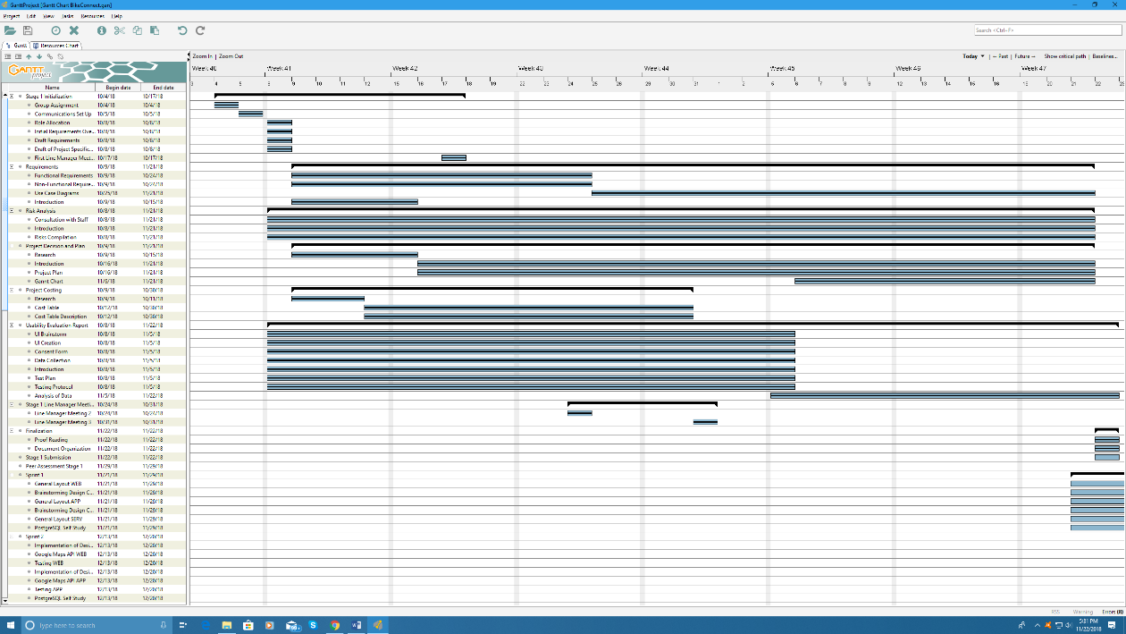

**Stage 2 (Sprints 1 – 5)**

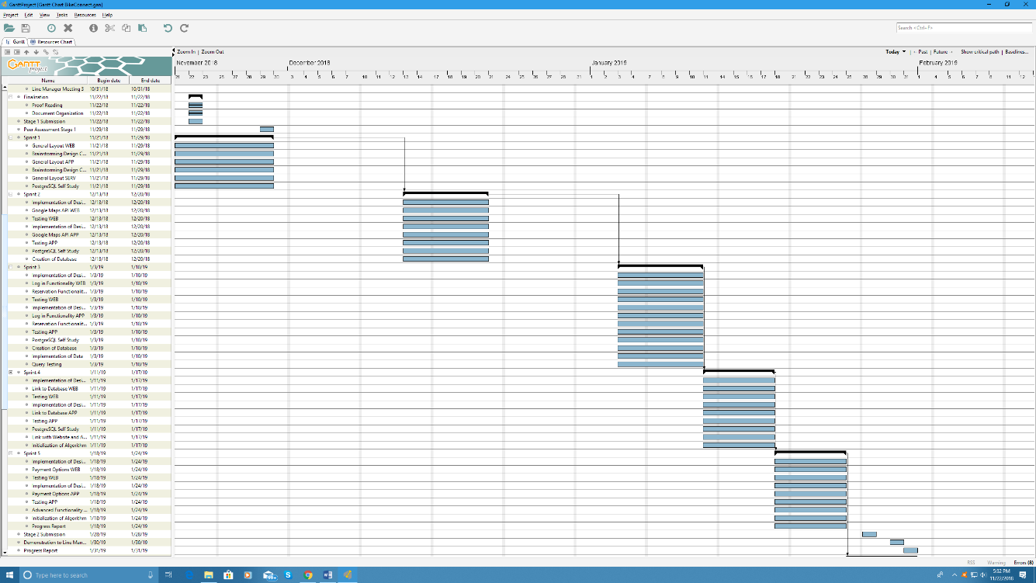

**Stage 3 (Sprints 6 – 12)**

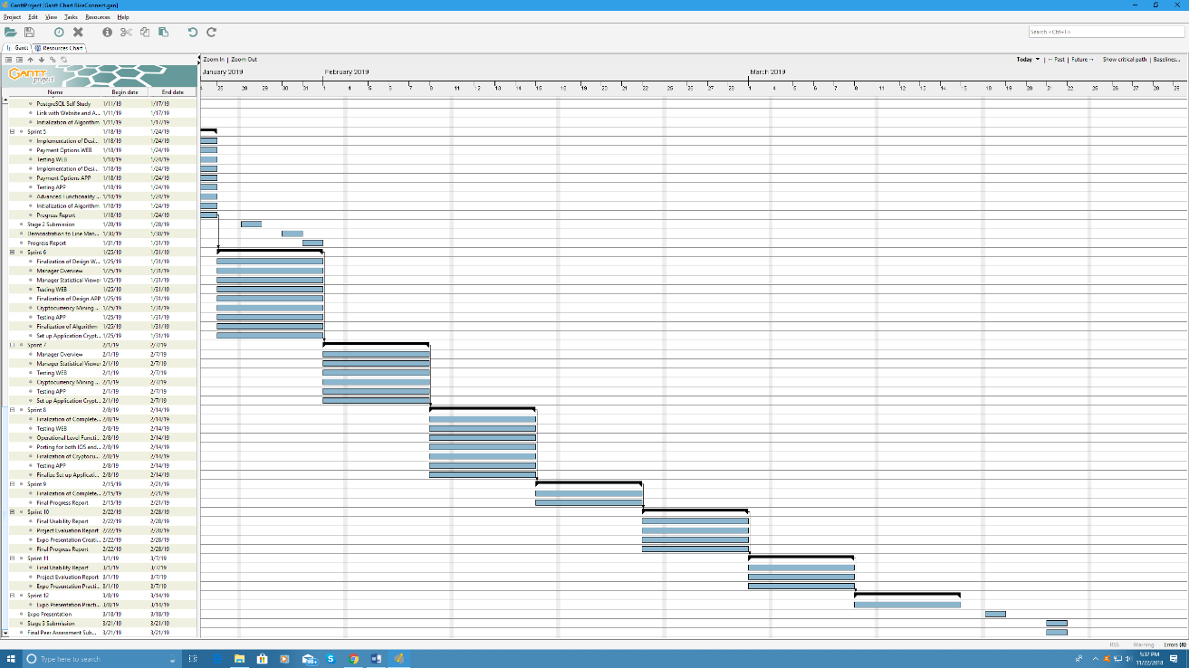

The above plan, the original, was effective for stage 1 and the initial portion of stage 2 but soon the team fell behind due to lack of manpower and somewhat overestimation in how fast task could be completed. The original plan also allowed for ample setup and practice for the final exposition, but this too was adversely affected by the delayed production schedule, therefore the preparation for the expo was pushed into a few days right after production had ended.

In the new implementation schedule, there were several features cut in order to allow for developing of the main core features required by the client. One of which was the cryptocurrency feature that would have been a major undertaking and a cornerstone of what would have made our application different and stand out from the competition. The actual implementation schedule can be found in this document under B Final Usability Evaluation, 6.0 Implementation Methodology. Therein it is clear to see that the number of tasks completed per sprint is greatly reduced from the original plan. The original plan also called for the group to split up into two teams a backend and a front-end team that would work simultaneously on their respective parts as to boost productivity, this never occurred due to again lack of manpower.

2.0 Implementation

2.1 Success of Implementation Approach and Version Control

The SCRUM implementation approach that was used in the development of the application had varying degrees of success with the team. The short sprints with focused goals and testing of those goals were very helpful in keeping the team focused and productive. This also allowed for the necessary changes during the development phases in the timeline and amount of functionality, this was a critical element that allowed us to deal with the problems of collaboration within the group by being very flexible. Although we did cut functionality the way SCRUM is set up it was still possible to maintain the minimum requirements in certain fields by constantly monitoring the changes being made to the development schedule. An example of this was in sprint week 8 when we had a discussion about the features that we had aimed to achieve but at this point realized would not be possible given the time left and the manpower available to the group, due to the SCRUM meeting and our Scrum manager/group leader alerting the group to the issue at hand and what the minimum requirements were for each element of the application we effectively changed course that week and developed an entirely new schedule for the upcoming weeks. The flexibility and constant communication of SCRUM allowed us to easily and efficiently change course with all working group members being on the same page.

SCRUM did have it’s negatives mainly again due to the lack of collaboration in the group the entire team’s focus was rarely present and therefore the full extent of the usefulness of SCRUM agile design was never reached throughout the development. Also, the pace of SCRUM did not allow for unforeseen complications this was the case when our application development framework Apache Cordova had complications when attempting to run on Android and IOS in sprint week 11 forcing us to have to abandon the tasks, for a day, set that week and focus our efforts into solving the problem at hand. This resulted in only partial completion of otherwise fully functioning features which could not have been made up for as time did not permit it and the final sprint was not changeable.

The version control used by the team was GitHub whereby changes are recorded and displayed for the entire team along with a save for each change, therefore allowing for easy and quick backtracking in case of an error. The system worked relatively well for about halfway through the sprints when it started to delete certain added code seemingly at random. We believe the errors started to occur when busy development times occurred within the group and we were all pushing updates to the system after one another. The utility of GitHub along with its moderately difficult user interface created a good blend of a dynamic version control with a lot of adjustability and customization, had it not been for the errors it would have been easy to recommend however the errors, mainly the loss of added code and changes, did cause a lot of confusion and problems for us at critical phases in the development cycle.

2.2 Languages, Tools and Techniques

PHP:

PHP is a general-purpose programming language that is designed for web development. It’s a scripting language used to automate tasks.

It was used to interface between the web app and PostgreSQL, allowing its data to be read and edit the Database. It allows the app to request PHP script files that interact with the database, it also allowed or denied requests according to its scripting.

HTML:

HTML is a standard mark-up language that is used to create web pages and applications.

CSS:

Cascading Style Sheets basically describe how HTML elements are displayed, used for stylistic purposes.

BOOTSTRAP:

Bootstrap is the most popular CSS Framework for developing responsive and mobile-first websites. We used bootstrap for its extensive design frameworks that assisted us in developing the UI of the final product.

Apache Cordova:

Apache Cordova is an app development framework that allows apps to be ported directly to any platform, allowing us to have just used JavaScript and HTML including AJAX, jQuery, and XMLHttpRequest.

JavaScript:

Javascript is a programming language for the web, it can update both HTML and CSS, it can also calculate, manipulate and validate data.

Postgre SQL:

PostgreSQL is a DBMS that allows storage and organization of huge chunks of data, which is used to manage the information about bikes and hubs and other data regarding BikeConnect.

It compared to MySQL has much faster read and write speeds, this

was one of the reasons why we opted to use PostgreSQL,

Google Maps API:

Google Maps API is useful to keep track of the bike hubs and bikes, connecting an app to the Google MAP API helps make sure that the locations are accurate and credible.

PayPal API:

The PayPal API although not fully implemented, was something that would’ve been implemented if we had a domain and a bank account to transfer to. It allows people to have a system that’s quite reliable and secure.

SCRUM Agile:

We used a SCRUM framework to complete this project since it is something that could easily be broken down into multiple small pieces and finish each part and connect it with the other parts, it’s also very good with smaller groups.

3.0 Product

3.1 Functionality Achieved

For this part of the documentation, we will be assessing if the user-requirements we intended to implement in stage one of this project have been implemented, and if so, to what extent. This is a list of all user requirements in our system, both functional and non-functional. Those that were not implemented will be a top priority to be considered for the BikeConnect 1.1 application.

|  |  |
| --- | --- |
|  | Fully Implemented |
|  | Partially Implemented |
|  | Not Implemented |

Prioritized Functional Requirements

**FR - Functional Requirement**

**NFR - Non-Functional Requirement**

**U - User**

**S - System**

**Prioritization denoted with the use of MoSCoW:**

**M - Must Have feature**

**S - Should Have feature**

**C- Could Have feature**

**W- Want but not Necessary feature**

**The following format is used to denote our function and non-functional requirements as per the abbreviations above.**

**User/System - Requirement ID - Requirement Description - MoSCoW prioritization**

1. S - FR 1 Each bicycle registered to the system must have a navigation system allowing their location to be tracked throughout the city- M

The bicycles in the system must have a navigation system (either GPS or through a Mobile Data Device) to track their current location in live time and to allow the rest of the system to function.

1. S - FR 2 The Mobile-Application must allow the user to book bicycles - M

The customer can select a bicycle and request booking for a certain time period via the application interface. For this transaction to occur, the account details of the user (e.g. name, sex, DOB) will be required along with the access to their location.

1. U - FR 2a The bicycles available for booking from customers must be seen on an Interactive Map - M

The bicycles available for booking will be available for selection by customers on an interactive map on the application.

1. U - FR 2b The mobile application must allow for users to report problems with the bicycles - M

The customer can alert the operations center in case of breakdown or other problems associated with the bicycle.

1. U - FR 3 The web-based application must allow personnel to monitor or change the status of bicycles- M

Operational Personnel can monitor and change the status of the fleet or individual bikes which includes status, location, and rental information.

1. U - FR 3a The bicycles will be monitored on the interactive map - M

The operational personnel will be able to monitor the entire fleet on a map within the application which will be a different view to what the Customers can see.

1. U - FR 4 The users are able to access their user account on the BikeConnect website - M

The personnel will be able to access and alter their account details on the website and track. These include the distance traveled, transaction receipt and the location of travel.

1. U - FR 4a The users can add funds or connect their payment information to their account using the application or website - M

The users can add funds to their personal wallet using the website in order to pay for the transactions to pay for the bike bookings.

1. U - FR 4b The users can connect their social media to their accounts - C

The users can add their social media to their accounts for easier access as well as to provide the solution with statistical information (for advertisements and customer needs feedback/analysis)

1. S - FR 5 The system will charge extra if a user does not return a bike within 1 hour after the agreed booking time - S

The system will calculate a rate based on the duration of the booking and will charge this rate by the hour if the bike is not positioned at a verified bike station exactly 1 hour after the agreed booking time.

1. S - FR 5a The System will send a notification to the management and will charge a fine if the gear was not returned to the same station as the booked bike was parked in - S

Once confirmed by an operator, If the equipment booked was not returned to the station the bike was parked at, a notification will be sent to management and a precalculated fine will be administered to the user who booked them.

1. U - FR 6 The users are able to make bookings on the BikeConnect website - M

Similar to the bikeConnect application, users can make bike reservations on the website with the same interactive map as well using their same account.

1. U - FR 7 The users will be given the option to book additional biking gear when booking a bike at a particular location - S

Users can reserve helmets, headphones, special-needs items when booking a bike which will be available at the station where it is parked or be delivered if it is not available.

1. U - FR 7a Operational employees will be notified if biking gear is requested and is not available at the bike station for delivery - S

If the requested gear is not available at the station (in lockers with key codes given to the customer who booked them, then the operational employee can personally deliver them to the station before the booking time.

1. S - FR 8 Reports on the system and individual locations will be created at set times every day - M

Summarized information of bike usage, rental and other relevant information will be created for delivery and analysis by the management personnelle.

1. U- FR 9 The user will be prompted at intervals of times close to the end of the booking to remind them to park at a nearby station - S

The user will be reminded towards the end of their booking session to park the bike at a nearby station.

1. U- FR 9a The user will be prompted to notify the system when the bike and gear have been parked and stored at a verified location - S

When the user has parked the bike and returned all borrowed equipment back to a verified station, they will be prompted by the application to notify the system that they have successfully done so.

1. S- FR 9b The system will cross check that the bike and equipment has been stationed at the said location - M

The system will check with the bikes navigation system to make sure that the bike has been stationed at the predefined location at the end of the booking.

1. U- FR 9c The operator can report a stolen or damaged beyond repair bike if deemed necessary - M

If the Operator has found the bike to be damaged beyond repair (vandalism) or if there has been a glitch in the system and the bike is not at the location specified, an option will be given to report the incident to the managers, who will then report the authorities.

1. U - FR10 - Users can request a Refund a booking incase it was accidental or due to booking timeout - W

Immediate refunds are granted to the user who has made an accidental booking or the estimated time of arrival (ETA) of the user has timed out on the application.

1. U/S - FR10a - Fines are not imposed on users who had to deliver the bike back substantially long after the agreed booking hours under viable circumstances - W

Due to reasons such as unexpected medical issues, natural disaster or any reason seen as viable, no fines will be issued to the user.

1. U - FR10b - If such circumstances occur, the user must provide proof through a feature in the mobile application or website which will be reviewed by management - W

The reason as to cause the delay must be provided (in textual form) via a feature in the application. This will be reviewed by a member of management and is when the decision will be made.

1. S- NFR - The system should allow new users to create and verify their own accounts - M

New users can register and verify their identity.

1. S - NFR - The system should be continuously updated and be responsive to users quickly - C

Software should be fast and be updated to provide accurate and live information to users and operators

1. S - NFR - The system must be and remain Secure - S

Customers information must be secure and private and not be disclosed to any third party entities.

1. S - NFR - The system should be user-friendly in design and be functional - M

The application and the website must be user-friendly and also allow good collection of accurate feedback during the usability experiment part of the project.

1. S - NFR The system will implement Custom/ Multiple views depending on the user - M

Most requirements have been met at this stage of development for BikeConnect however the requirements that were not met are due to the lack of manpower and challenging new technologies that we incorporated into the application.

Instead of implementing these requirements marked above we decided to focus on what was of critical importance to the proper functioning of the application and what specifically the client demanded features were. An example of this is the feature that was implemented whereby users can create and submit reports/complaints linked to their booking via the application that can be monitored by the management/operators.

The partially completed highlighted requirements indicate that the functionality, or partial functionality, is already built into the application but being used in a different way and therefore does not provide the exact functionality of these requirements.

3.2 Special Features

There are several special features that we included in the development of BikeConnect that were not part of the main requirements for the system. The first is the focus on the legal aspects of operating a bicycle in the United Arab Emirates with the team creating a full legal page, outlining the various laws and penalties. In addition to the legal page the application will give the user alerts on the legal requirements and also will link to the legal page so that they are not only alerted to them but also have an easy and direct way to access all legal documentation.

The other special feature that we decided to implement was a payment system utilizing the PayPal API for easy and convenient payment methods straight into a set up BikeConnect company account. The booking confirmation page had been created and the API fully set up however that is where development halted as we reached the end of the SCRUM cycle and required an actual bank account to proceed father from PayPal side, therefore this is only partially implemented and will be fully in future updates.

The last special feature, apart from the challenging technology like Apache Cordova and PostgreSQL, would be the secure token login system that prevents users from accessing different parts of the application while logged in and also allows for tracking login-ins of all users via the database for administration and security purposes.

3.3 System Robustness and Team Satisfaction

As leading technical manager for the front-end design and having discussed with the whole group about their opinions on the final version of the product, there is a lot to be discussed in terms of how we could have improved our functionality and design decisions. First, the whole team agrees that given the time frame we had, we created an application that not only adheres to the purpose for which it was created but does so in a stylish way that would be appealing to a real-life customer in case it was implemented. The final version of the system allowed a user to book a bike with custom order details, cancel orders, file a complaint as well as maintain an account with the company for future use of the system.

This briefly summarizes the main features which the user has access to, but some of the features that we had issues with or couldn’t implement in time, were things such as: allowing the user to edit their booking ahead of time, allowing them to see pictures of the bikes and the gear that they were ordering as well as implementing a fully functional payment system. The editing system which would have allowed the user to change their booking, would have had to be a separate page or stuffed somewhere onto the main page (adhering to the one page design layout that the group had decided on) but finding the right form or web page design seemed quite difficult and in the end, the decision was made to cut it out. The pictures could have been added as a simple pop-up when selected from the drop-down menu or been a redirected page when viewed from the pricing page and we could have implemented this had we had some extra time. Finally, the payment gateway to PayPal required an actual bank account to be linked with a domain that we would have had to host the website on for them to accept the payment and redirect to our page which we simply did not have access to.

3.4 Bugs and User/Operator Constraints

As far as bugs are concerned, there were none which completely broke our applications functionality, that we as a team found through extensive testing as well as during and after the expo in which many people interacted with and gave feedback about our web-application. There were however some visual bugs in the mobile application versions of the web-application which Apache Cordova created during the build compilation. These visual bugs were confined to the tables being extended off the screen which was because of the scalable CSS code. I attempted to fix this issue, but it would result in the tables of the browser-based web-application being completely thrown off the screen so I reverted to the original version which worked to some extent at least.

The administrator application view also lacked in the number of features we had originally planned for it. Some of the extra features that were still in the development pipeline when we finished were the ability for the operator to send bikes to the respective vendor for repair, delete complaints off the board or make the system clear them after a certain period and manage the relocation of bikes throughout the city. Visuals wise, the administrator page was perfect bar the same table issue as previously discussed in the user view.

The final system we created is a solid application both front and back-end which I believe is to quite a high standard. The PHP, AJAX and database design held up incredibly well and allowed the system to operate flawlessly and acts as a concrete foundation for the functionality of the system. There are several complex queries used to retrieve and post information to the database and when paired with the performance-oriented PostgreSQL, makes the system fast and extremely durable. Considering constructive self-criticism, the overall features of the application could have been increased and the design is made slightly more intuitive for the less experienced at computers.

3.5 Usability Summary

The usability results were as expected mainly positive with constructive feedback about small UI improvements and additional features that the users wanted. From looking at the statistical graphs it’s clear that on some topics like ease of use and design all the participants of the test had very similar positive responses which are a good indicator that the UI and therefore the UX of BikeConnect can be considered a success.

While conducting the test’s the principal test conductor noted that the users had very little issues using the application and apart from some small details, like the input of bike ID that did not go down well, overall everything was well labeled and design decisions were considered successful.

The user’s response to what they enjoyed the most about BikeConnect is also intriguing as there were multiple different answers indicating that multiple parts of the application were designed well enough to be apricated and that overall consistency was high throughout the design.

The feedback from the users has been noted down and will be implemented/fixed in the next version of BikeConnect as the testing was conducted towards the very end of the production cycle and no time was available in order to implement them.

Additional individual responses to the test can be found at section B Final Usability Evaluation, 4.1.

E. Future Work and Conclusion

1.0 Future Work

The first version of BikeConnect has been completed however due to unforeseen circumstances a variety of functionality that was initially planned was not implemented and this will now be discussed.

* Social media integration include links for social media login and links to BikeConnect social media pages.
* Additional alert’s in terms of the manager/operator view for when gear supply becomes low or bikes aren’t returned on time, for users when they have gone over time.
* Automatic implementation of fines to users who have gone over the allotted time slot.
* Full integration of the PayPal payment system, with transaction history stored in the database.
* Additional statistical data being processed and displayed in the manager/operator view.
* Full modification of bookings by the user.
* Email system to send booking confirmation and transaction history to the users inputted email.
* Parked bike location will be saved and displayed to the user

These improvements are the top of the list for development requirements for version 2.0 of BikeConnect along with the enhancements of the UI as indicated by the testing performed. Another useful future feature recommended to us by one of our test participants was the addition of a CAPTCHA before the user can register for a new account in order to prevent bots from creating spam accounts.

The current implantation of BikeConnect is run from a local host and thus far has not been set up on a dedicated server that is hosted on the internet, this would undoubtedly be a top priority for the future as the ease of access and availability will enhance the overall experience and reduce development time.

2.0 Conclusion

The intended purpose of this application was to allow users an easier and digital way of reserving bicycles while making it easier for the company to manage the system, combined with a variety of features and good user interface. We the development team believe we have achieved that but the road here has been rough, very rough in fact but due to the efforts of a few and the guidance of our excellent line manager the end result is something we all here are proud of.

F. Appendix

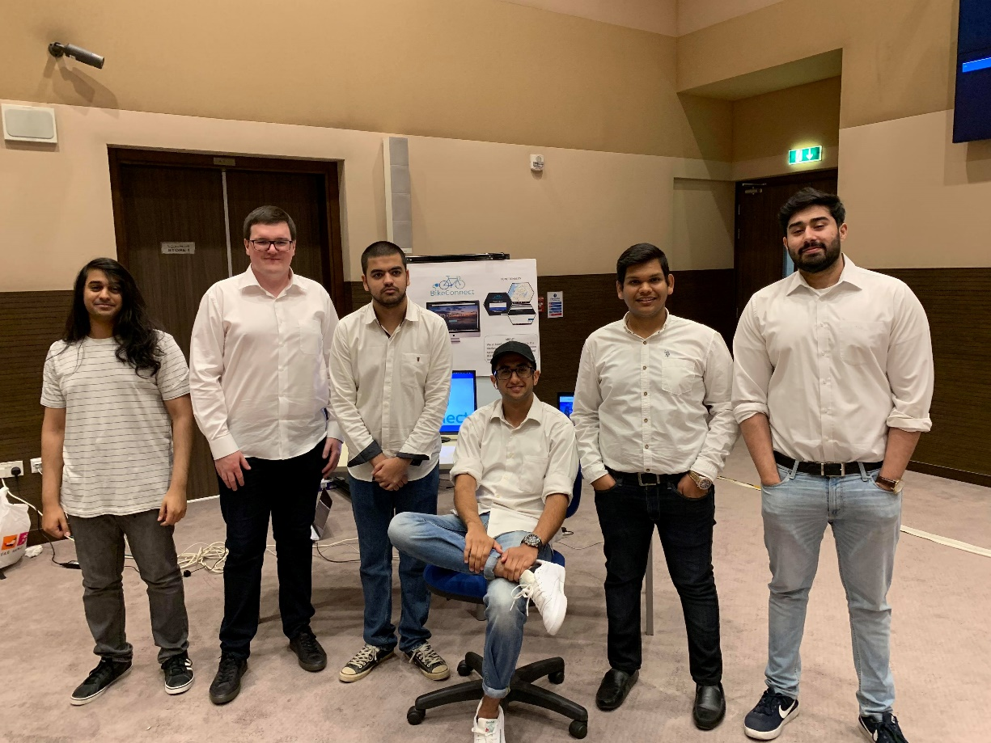

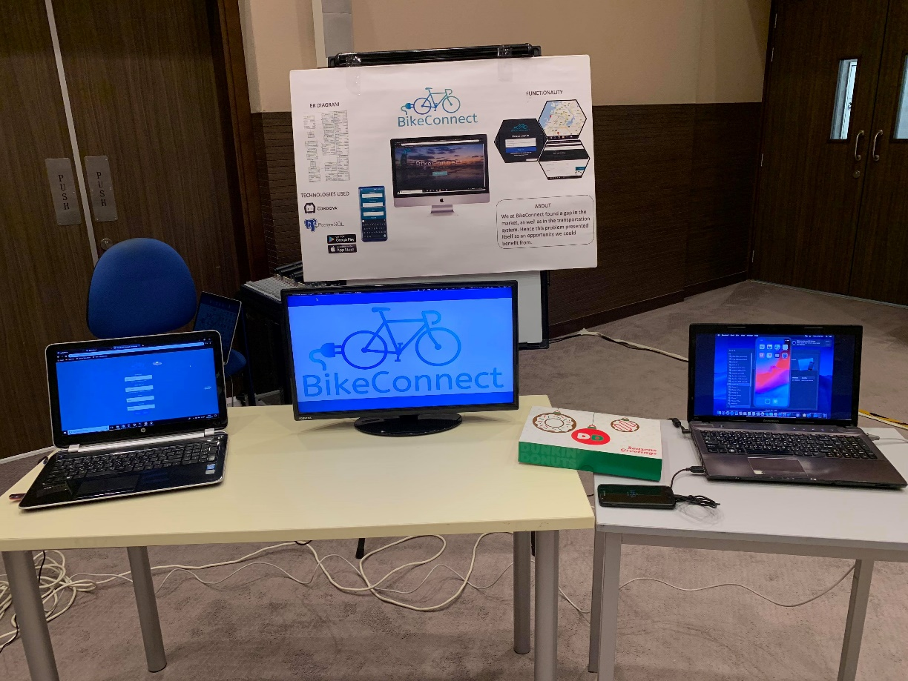

The Images above are marketing material taken during the Expo of the BikeConnect application.

Image Sources from D Project Evaluation, 2.0 Implementation, 2.2 Language, Tools, and Techniques (In order of appearance)

* <https://www.php.net/>
* [www.w3.org](http://www.w3.org)
* <https://www.w3schools.com/whatis/whatis_css.asp>
* v4-alpha.getbootstrap.com
* <https://www.g2crowd.com/products/apache-cordova/reviews>
* <https://www.pluralsight.com/paths/javascript>
* <https://www.zdnet.com/article/has-the-time-finally-come-for-postgresql/>
* <https://commons.wikimedia.org/wiki/File:GoogleMaps_logo.svg>
* <https://www.paypal.com/us/home>
* <https://www.scrum.org/resources/what-is-scrum>